

State of Nevada
Joint Information System Operations Plan



Nevada Department of Public Safety
Division of Emergency Management/Homeland Security

Updated: June 2017

This page is intentionally left blank

DOCUMENT CHANGE CONTROL

Version | Date | Summary of Changes | Name
Original | April 2011
Version update | October 2012 | Coordinated with DEM staff and PIOs | Gail Powell
Version update | August 2013 | Coordinated with State PIOs and SCEMP | Gail Powell
Version update | March 2014 | Leadership Update  Private Sector | Gail Powell
No modifications | 2015 | N/A | No modifications
Version update | September 2016 | Development of a new annex to the State Comprehensive Emergency Management Plan (SCEMP) formalizing the creation and operation of the state Joint Information System (JIS). It clarifies that the JIS includes all state Public Information Officers (PIOs) as well as the PIOs for partner jurisdictions and non-government organizations (NGOs). It formalizes a system for training the state PIOs for work within the JIS, as well as within a Joint Information Center (JIC) and the State Emergency Operations Center (SEOC). | Gail Powell
Version update | June 2017 | Nevada 211 emergency contract annex | Gail Powell
Version update | July 2018 | Incorporate notification and resource requests for assistance with ADA and 508 Compliance. | Gail Powell

TABLE of CONTENTS

1. Overview Page 1
1.1. Purpose Page 1
1.2. Background Page 1
1.3. Authorities Page 1
1.4. Hazards Page 2
1.5. Critical Assumptions Page 2
2. Mission and Objectives Page 2
3. Components of the Joint Information System Page 3
3.1. Emergency Support Function #15 – External Affairs Page 3
3.2. State Joint Information Center Page 4
4. Execution Page 5
4.1. Governor’s Intent Page 5
4.2. Concepts of Operation Page 5
4.2.1. Phased Operations Page 6
4.2.1.1. Phase 0: Steady State Page 6
4.2.1.2. Phase 1: Increased Threat Page 6
4.2.1.3. Phase 2: JIC Activation and Employment Page 6
4.2.1.4. Phase 3: Recovery Page 6
4.2.2. State JIC Activation Page 7
4.2.3. State JIC Organization Per NIMS Type Page 7
4.2.3.1. Type 5 Incident Page 8
4.2.3.2. Type 4 Incident Page 8
4.2.3.3. Type 3 Incident Page 9
4.2.3.4. Type 2 Incident Page 9
4.2.3.5. Type 1 Incident Page 10
4.2.4. JIC Layout Page 11
4.2.5 Demobilization Page 11
4.3. Key Roles and Responsibilities Page 12
4.3.1. Command Positions Page 12
4.3.1.1. ESF #15 Page 12
4.3.1.2. Assistant PIO JIC Manager Page 14
3.3.1.3. Administrative Support / IT Page 14
4.3.2. Media Relations Branch Page 14
4.3.2.1. Assistant PIO for Media Relations Page 15
4.3.2.2. Media Relations Specialist Page 15
4.3.2.3. Media Logistics Page 16
4.3.2.4. Field Specialist Page 17
3.3.2.5. Media Monitoring Analyst Page 18
4.3.3. Research and Writing Branch Page 18
3.3.3.1. APIO for Research and Writing Page 19
4.3.3.2. Content Development Specialist Page 19
4.3.3.3. Rapid Response Specialist Page 20
TABLE of CONTENTS (Continued)

4.3.3.4. Translation Specialist Page 20
4.3.4. External Relations Branch Page 20
4.3.4.1. APIO for External Relations Page 20
4.3.4.2. Local Jurisdiction Liaisons Page 21
4.3.4.3. State Agency Liaisons Page 22
4.3.5. Special Projects Branch Page 22
4.3.5.1. APIO for Special Projects Page 22
4.3.5.2. Web Page Specialist Page 22
4.3.5.3. Call Center/Hot line Specialist Page 23
5. Coordination Page 23
5.1. Governor’s Activation of the JIC for Administrative Purposes Page 23
5.2. SEOC Activation of the JIC in Response to an Incident Page 23
6. Plan Maintenance Page 23
7. Training and Exercise Page 24
8. Annexes Page 24

Annex A: Job Aids
Job Aid 1 – Establishing the Initial Response Page 1
Job Aid 2 – Establishing a JIC Page 2
Job Aid 3 – Demobilizing a JIC Page 3
Job Aid 4 – Developing an Operating Schedule Page 4
Job Aid 5 – Producing a status Board Page 5
Job Aid 6 – Validating Rumors Page 6
Job Aid 7 – Providing Media Briefing Page 7

Annex B: Job Action Sheets
Job Action Sheet – JIC - PIO Page 1
Job Action Sheet – JIC – JIC Manager Page 3
Job Action Sheet – JIC – APIO for Media Relations Page 5
Job Action Sheet – JIC – APIO for Research and Writing Page 7
Job Action Sheet – JIC – APIO for Special Projects Page 9
Job Action Sheet – JIC – APIO for External Relations Page 11
Annex C: Forms
Activity Log (ICS 214) Page 1
Assignment List (ICS 204) Page 3
Incident Status Summary (ICS 209) Page 5
General Message (ICS 213) Page 9
DEM Action Request Form Page 10

Annex D: References, Worksheets and Examples
Daily Checklist Page 2
Planning P Page 3
` JIC Staff Self- Assessment Survey Page 4
Daily Brief Worksheet Page 5
TABLE of CONTENTS (Continued)

Media Assessment Worksheet Page 7
Media/Social Media Analysis Worksheet Page 8
Query Records and Technology Page 9
Writing Guidelines for News Release Page 10
Sample News Release Page 11
Media Briefing Worksheet Page 12
Content and Writing Guidelines for Bloggers Page 13
Speakers Preparation Worksheet Page 15
Spokesperson Request Worksheet Page 16
Media Briefing Worksheet Page 17
Field Specialist Equipment and Communication Checklist Page 18
Opening Statement for Community Relations Interview Page 19
Sample Media Advisory (Media Briefing) Page 20
Sample Media Advisory (JIC Established) Page 21
Sample Public Service Announcement Page 22

Annex E: Acronyms

- Overview
During an emergency, disaster or major event, the State of Nevada must provide accurate, coordinated, consistent and timely information to the citizens of Nevada. Information during a time of crisis will be one of the most vital resources that will instill confidence that all levels of government are working in partnership to restore essential services and help individuals begin to put their lives back together. Using the concepts put forth in this plan, the State of Nevada will be able to communicate vital information to the citizens of this state.

  - Purpose
The purpose of the State of Nevada Joint Information System Operations Plan (OPLAN) describes an integrated strategy to provide coordinated information during an emergency, disaster or major event through the State Joint Information System (JIS) to support statewide and local response efforts. This OPLAN describes the state JIS mission, concepts of operations, organization structures and it identifies roles and responsibilities to meet mission requirements.

  - Background
This OPLAN is a result of a focused process using a systematic planning approach to bring in state agencies and local jurisdiction stakeholders in the development of this plan. It is consistent with the National Incident Management System (NIMS) concept of the JIS, the State Comprehensive Emergency Management Plan (SCEMP) and the Nevada All Hazards Catastrophic CONPLAN.

  - Authorities
- Nevada Revised Statutes (NRS) 414
- Nevada Revised Statute, Chapter 239C (Homeland Security)
- Nevada Revised Statute, Chapter 433 (State of Emergency)
- Nevada Revised Statute, 277.080 – 277.180 (Inter-local Cooperation Act)
- Nevada Revised Statute, Chapter 415 (Emergency Management Assistance Compact)
- State of Nevada Comprehensive Emergency Management Plan
- Robert T. Stafford Disaster Relief & Emergency Assistance Act,(as amended),42 U.S.C. 5121
- Emergency Planning and Community Right-to-Know Act, 42 USC Chapter 116
- Emergency Management and Assistance, 44 CFR
- Hazardous Waste Operations & Emergency Response, 29 CFR 1910.120
- Homeland Security Act of 2002
- Homeland Security Presidential Directive. HSPD-5,Management of Domestic Incidents
- Homeland Security Presidential Directive, HSPD-3,
- National Response Framework
- National Incident Management System
- Incident Command System

  - Hazards
- Wildfire is the number one threat for Nevada. On a yearly basis the Nevada has the potential for millions of acres lost to wildfire, many fires approaching populated areas.
- Nevada is the number three state in the nation for seismic activity. Hundreds of earthquakes strike Nevada every year; some of which have the potential to cause major property damage and loss of life.
- Flooding of Nevada’s rivers and flash flooding of streams and dry washes have caused significant damage in the past.
- Las Vegas is a premier tourist destination for millions of visitors from across the globe and is considered a significant target for terrorist threat.

Nevada faces many more natural and man made threats in addition to those mentioned above, and due to that fact, this plan uses an all hazards approach.

  - Critical Assumptions
- During emergency situations, the general public and media will demand information about the emergency situation and instruction on proper self-protection actions.
- The local media, particularly television and radio, will perform an essential role in providing emergency instructions and the most current information to the public.
- The State Joint Information Center (JIC) at its primary site at the State Emergency Operations Center (SEOC), or at an alternate site, will have electricity, telephone and other forms of communication, and have the ability to monitor local and national news through television, radio and/or the internet.
- The State JIC will have enough trained staff and/or volunteers to perform its mission.

- Mission and Objectives
The mission of the State of Nevada Joint Information System is to provide a structure and system for developing and delivering accurate, coordinated, consistent and timely messages; developing, recommending, and executing public information plans and strategies on behalf of the Office of the Governor and the State Emergency Operations Center; advising the Office of the Governor, the State Emergency Operations Center, and local jurisdictions affected by disasters concerning public affairs issues that could affect a response effort; and controlling rumors and inaccurate information that could undermine public confidence in the emergency response effort.

Mission Essential Objectives
- Instill confidence in the state that all levels of government are working in partnership to restore essential services and help individuals begin to put their lives back together;
- Work with the media to promote a positive understanding of federal and state response, recovery and mitigation programs;
- Provide all target markets with equal access to timely and accurate information about disaster response, recovery and mitigation programs;
- Manage expectations so that disaster victims have a clear understanding of all disaster response, recovery and mitigation services available to them; and
- Support local efforts to reach disaster victims with specific program information.
- Components of the Joint Information System

  - Emergency Support Function #15 – Public Information
The Emergency Support Function (ESF) #15 –Public Information is a component of the SEOC and plays the primary role of coordinating information for the state in support of local jurisdiction incident response. ESF #15 also is responsible to coordinate the efforts of state agencies for gathering and disseminating emergency information to government officials, the general public and the news media to contribute to the health, safety and welfare of the communities of Nevada during an emergency or a disaster. Nevada employs 18 ESFs in its SEOC. Each ESF has a main function and several support functions as determined by the State’s coordination of response resources at the request of the local jurisdiction to any incident. ESF #15 falls under the Operations Section and is responsible to coordinate public information mission assignments as directed by the Operations Section Chief, but also serves as the main advisor for public information and external affairs to the SEOC Manager (See Figure 2).

The JIC is a component of ESF 15. The JIC may be activated at the discretion of ESF #15. When the ESF #15 receives an external affairs mission assignment from SEOC Operations, if activated, the JIC activities ensure the coordinated and timely release of incident-related prevention, preparedness, response, recovery and mitigation information to the public (See Figure 3).
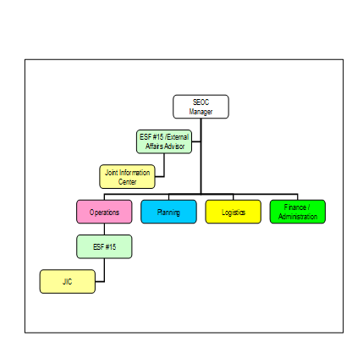
Figure 2 ESF #15 within the Framework of the SEOC
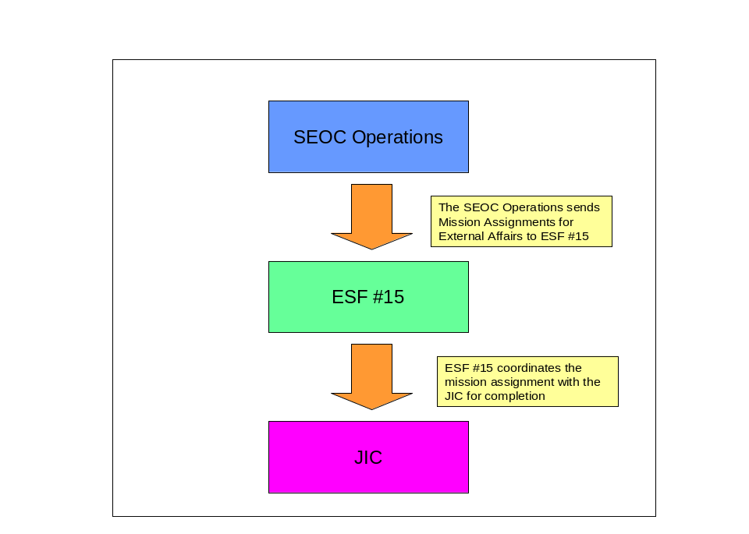
Figure 3: ESF #15 Mission Assignment Coordination

  - State Joint Information System – Annex R

Purpose
This annex to the State Comprehensive Emergency Management Plan (SCEMP) formalizes the creation and operation of the state Joint Information System (JIS). It clarifies that the JIS includes all state Public Information Officers (PIOs) as well as the PIOs for partner jurisdictions and non-government organizations (NGOs). It formalizes a system for training the state PIOs for work within the JIS, as well as within a Joint Information Center (JIC) and the State Emergency Operations Center (SEOC). It also clarifies who maintains responsibility for leadership of the JIS.

JIS Mission
The mission of the JIS is to coordinate the efforts of all Public Information Officers in the state who may join in public safety efforts at any time. This mission extends from the prevention, preparedness and mitigation phases of emergency management through response and recovery. The JIS goal is to improve communications with the public by creating unified messaging and greater efficiency among agencies, both governmental and non-governmental, both during emergency situations and non-emergency times.

During emergency situations the JIS provides a structure and system for developing and delivering coordinated interagency messages; developing, recommending, and executing public information plans and strategies on behalf of the Incident Commander; advising the Incident Commander concerning public affairs issues that could affect a response effort; and controlling rumors and inaccurate information that could undermine public confidence in the incident response effort.

Because emergency situations lie outside the normal routine of the PIOs serving on the JIS, training and exercises are essential to the success of the system and are prescribed as part of this Annex. It is more important for the JIS members to become familiar with each other and the various tasks to be performed than it is for them to memorize any specific function within the JIS or JIC.

JIS/JIC Clarification
FEMA defines the Joint Information System (JIS) as “the structure for ensuring that PIO functions are coordinated and integrated,” saying it “provides the mechanism to organize, integrate, and coordinate information to ensure timely, accurate, accessible, and consistent messaging across multiple jurisdictions and/or disciplines with nongovernmental organizations and the private sector.” (FEMA IS-702.A)

The JIS integrates incident information and public affairs into a cohesive organization designed to provide consistent, coordinated, accurate, accessible, timely, and complete information during crisis or incident operations.

The JIS is not to be confused with the Joint Information Center (JIC), which is “a location where personnel with public information responsibilities perform critical emergency information functions, crisis communications, and public affairs functions.” (FEMA IS-702.A)

The JIC is a central location that facilitates operation of the JIS. If possible, it is advised to have location(s) identified that could be used as a JIC before an incident occurs; ideally, in close proximity to the SEOC. It is important that these locations meet the working needs of the PIO function and allow easy access for the media. Once a JIC has been identified, it is recommended to have appropriate equipment and other resources available and operational. The PIO should develop standard operating procedures on the actual use of the JIC and the equipment and staff that may be needed.

Sample Joint Information Center (JIC) Organizations and Functions
Initial Response or Local Incidents

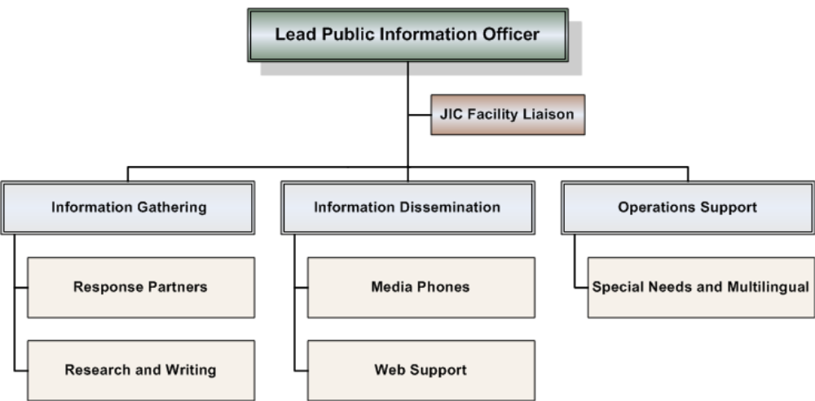

(From; Basic Guidance for Public Information Officers, FEMA517, November 2007)

In modern emergency management practice, a JIC may be virtual, with its functions performed by trained PIOs operating in different locations with the common goal of information coordination during an emergency situation. A JIC may also be considered a satellite JIC if it is set up near the scene of emergency management efforts rather than at a central office.

Any JIC may be considered a subset of the JIS, since its personnel are drawn from JIS members, and its functions are merely JIS functions performed by multiple PIOs. A JIC may or may not be activated in an emergency, but the JIS always exists.

This annex specifically deals with the makeup and functions of the Joint Information System (JIS) as well as the training of its members. It also serves to clarify personnel designation and authority already outlined in Annex P - ESF 15: Public Information.

In 2016 the new Annex R – Joint Information System (JIS) was added to the State Comprehensive Emergency Management Plan (SCEMP) formalizing the creation and operation of the state JIS. It clarifies that the JIS includes all state Public Information Officers (PIOs) as well as the PIOs for partner jurisdictions and non-government organizations (NGOs). It formalizes a system for training the state PIOs for work within the JIS, as well as within a Joint Information Center (JIC) and the State Emergency Operations Center (SEOC).

Definition
The Nevada Joint Information System is the network of communicators who facilitate emergency management information sharing within the state.

Makeup
In terms of personnel, Nevada’s JIS is the network of public information officers in state government, local and county jurisdictions and tribes as well as private partners and non-governmental organizations who are likely to need to cooperate during any emergency. This includes the PIOs of hospitals, utilities, schools and volunteer organizations (sometimes referred to as VOAD or Voluntary Organizations Active in Disaster), such as Community Emergency Response Teams (CERTs) and Non-Governmental Agencies (NGOs) such as the American Red Cross as well as state, county and local PIOs.

The JIS always exists, even when the state is experiencing no emergency and when the members of its PIO pool are busy at their other jobs. Its purpose is to coordinate their efforts on any project related to public safety, although the importance of that coordination is magnified during an emergency response.

Key Functions
The JIS is organized and maintained by the public information officer for the Nevada Division of Emergency Management (DEM PIO). This staff member maintains an updated list of all the PIOs in the state who are likely to interface in any emergency, along with a record of successfully completed courses and relevant experience for each state PIO. He/she coordinates their efforts in training, exercises and networking gatherings. In an emergency situation, the DEM PIO also coordinates their efforts to perform these key communication functions:
- Directing communications from the State Emergency Operations Center Operations (SEOC) Manager (during SEOC activation) to the Governor’s office, both through the Governor’s Authorized Representative (GAR) and the Governor’s Communications Director (GCD); and to the Chief of the Division of Emergency Management (DEM Chief)
- Directing communications from the SEOC Operations Manager (during SEOC activation) and other authoritative information sources to the appropriate outlets for public dissemination (this may require research within and outside of the SEOC)
- Identifying and fact-checking information from the public and forwarding vetted information to the SEOC Operations Manager (during activation) and, concurrently, to the Nevada Threat Assessment Center (NTAC)
- Creating news releases, media advisories and news conferences for traditional news media
- Creating public messages for internet and social media dissemination
- Coordinating information from and to partner agencies through their PIOs
  - Including affected state agencies
  - Including affected local and county jurisdictions
  - Including appropriate utilities, hospitals and other non-governmental partners
This coordination is executed with a goal of unified messaging—multiple partners disseminating the same information, without discrepancy.
- Monitoring traditional and social media
- Identifying rumors and validating or refuting them
- Answering media inquiries
- For record-keeping and financial purposes, maintaining the Unit Log for ESF 15 during SEOC activation

Scalability
As part of the National Incident Management System (NIMS), based on approved Incident Command (IC) structure, the Joint Information System (JIS) is scalable to fit any incident.

The DEM PIO may perform these functions alone when the incident or situation is small enough for one person to handle all PIO functions pertaining to the incident. He/she may call up additional staff of PIOs to handle large incidents. The key consideration is that all essential functions applicable to the incident are performed in a timely manner.

Leadership
When the State Emergency Operations Center (SEOC) is activated, the DEM PIO serves as Lead PIO in ESF-15 unless another qualified PIO has been appointed by proper authority to fill that role. When the incident is large enough to require several people to perform essential functions, Lead PIO may appoint a JIC Manager, who will in turn activate a JIC, physical or virtual, with enough trained PIOs to perform all necessary functions and will assign specific functions to the appropriate personnel. Lead PIO may also directly appoint other PIOs to perform specific tasks if a JIC is not activated.

The DEM PIO may also assist a state agency or partner agency by coordinating efforts of PIOs, even when the SEOC is not activated. In such cases, the state agency in charge of the situation (for instance NDOT, for a transportation-related emergency) will take the lead and the agency PIO will serve as Lead PIO, with DEM PIO providing additional PIO staffing and coordination as requested.

The same principles of assistance apply to local or county emergencies: Unless and until a disaster is declared by the Governor, the local PIO remains Lead PIO, with the JIS providing assistance through the coordination of DEM PIO.

It is up to DEM PIO (unless delegated to a different Lead PIO) to choose how many PIOs to use for an incident, and what roles they are to play in relaying information.

Autonomy
A basic principle of the JIS is that it allows participating PIOs to perform their primary information function for their employers, either governmental or non-governmental, while simultaneously serving the state through the JIS as needed and appropriate.

Message Authority and Timeliness
As outlined in Annex P, the Governor’s communications director (GCD) (referred to in Annex P and elsewhere in the SCEMP as the Governor’s Press Secretary or GPS) is considered Nevada’s oversight authority for all matters of public and emergency information. However, due to the critical importance of delivering timely information during an emergency, this authority is limited by (1) the urgency of information which may save lives and property, (2) the volume of messages that may be handled during an emergency situation, and (3) the need for timely updates throughout the situation as tools for cooperating with and managing media.

During an emergency situation, Lead PIO will advise the Governor’s Communications Director (GCD) of the outgoing messages and GCD will have the opportunity to modify those messages within a brief, half-hour window of time—unless the urgency of the situation requires immediate dissemination of information. Knowing that the Governor’s intent is to save lives and protect health and property in an emergency, it is presupposed that potentially life, health or property saving information has the prior approval of the Governor and the GCD. In no instance may the GCD delay the transmission of emergency-related information to the public, traditional media or social media by more than 30 minutes. This preclusion does not apply to preventive safety messages, but only to messages pertaining to an active emergency situation.

Training and Exercises
In emergency management, training and exercises are the most important factors in preparedness. Because emergencies are a departure from normal activities, emergency management—including PIO involvement in an emergency situation—must be practiced in a realistic setting to create an experiential understanding of the roles, challenges and actions encountered and required in an actual emergency.

For the purposes of this document, “training” refers to classroom or individual engagement in an approved course of study that includes individual evaluation to ensure that prescribed learning goals have been met. “Exercise” refers to a simulation of an emergency in which participants play realistic roles and receive feedback about their actions.

PIOs may serve on one of four levels of participation in the JIS: leadership, senior state PIOs, state PIOs or non-state PIOs.

Training tiers reflect the four levels of service:

Leadership—the DEM PIO, Lead PIO in any response involving activation of the SEOC, JIC Manager, and all personnel who serve in the SEOC in ESF 15, must have the following training:
• €SEOC Basic Training – an overview of the SEOC and its role in a disaster
• €IS-100 Introduction to Incident Command System (or current equivalent)
• €IS-200 Basic Incident Command System (or current equivalent)
• €Introduction to WebEOC- Crisis Management Software (or current equivalent)
• €IS-700 – National Incident Management System (or current equivalent)
• €IS- 800B – National Response Framework (or current equivalent)
These courses are required by the National Incident Management System (NIMS) for all people who work within the SEOC. The NIMS also requires, within the first year of SEOC assignment:
• €IS-701 Multi-agency Coordination System (or current equivalent)
• €IS-702.A Public Information System (or current equivalent)
• €IS-703 NIMS Resource Management (or current equivalent)
In addition, PIOs in JIS leadership must complete the PIO classroom series within their first year of JIS service:
- G289/IS-29 Public Information Officer Awareness (or current equivalent)
- G0290, Basic Public Information Officers Course (or current equivalent)
- G291 Joint Information System/Joint Information Center Planning for Tribal, State and Local PIOs (or current equivalent)
PIOs in JIS leadership are encouraged to also take:
- E388, Advanced Public Information Officer (or current equivalent)

Courses beginning with the “IS” designation are Independent Study courses available online to anyone at any time through the FEMA Emergency Management Institute (EMI) at https://training.fema.gov. Classes with the “G” designation are provided in a classroom setting by DEM. The “E designation denotes classes only offered by FEMA at the Emergency Management Institute. Successfully completed courses should be reported to the DEM PIO.

Senior state PIOs—all Nevada state PIO IIs and unclassified communications directors are considered candidates for service in a JIC and candidates for the JIS leadership positions listed above. Therefore, all Nevada state PIO IIs and unclassified communications directors are required to complete all 12 of the above-listed classes within one year of either the adoption of this annex, or the first anniversary of their hiring date, whichever comes later.

State PIOs—all Nevada state PIO Is are eligible to serve JIS functions, and, as such, are required to receive the following training:
• €SEOC Basic Training – an overview of the SEOC and its role in a disaster
• €IS-100 Introduction to Incident Command System (or current equivalent)
• €IS-200 Basic Incident Command System (or current equivalent)
• €IS-700 – National Incident Management System (or current equivalent)
• €IS-702.A Public Information System (or current equivalent)
In addition, PIOs are encouraged to take the PIO classroom series of courses:
- G289/IS-29 Public Information Officer Awareness (or current equivalent)
- G0290, Basic Public Information Officers Course (or current equivalent)
- G291 Joint Information System/Joint Information Center Planning for Tribal, State and Local PIOs (or current equivalent)

If appointed for JIS membership by a supervisor, a state PIO is expected to complete this training within one year.

Courses beginning with the “IS” designation are Independent Study courses available online to anyone at any time through the FEMA Emergency Management Institute (EMI) at https://training.fema.gov. Classes with the “G” designation are provided in a classroom setting by DEM. Successfully completed courses should be reported to the DEM PIO.

Non-state PIOs—while not required to take formal classes, all PIOs considered part of the JIS are encouraged to get the same training required of state PIOs. PIOs on the official state JIS list are encouraged to consult the Nevada Division of Emergency Management training calendar and participate in appropriate courses when offered in their area. They are also encouraged to take the FEMA “IS” online courses listed above, and to report successful course completion to the DEM PIO.

While the DEM does not normally compensate employers or PIOs for their time or travel expenses, DEM offers these courses at no charge to PIOs serving the JIS.

Appropriately trained PIOs may serve in leadership roles even if they are not state employees if they are appointed by DEM PIO or Lead PIO. However, the top tier of courses is required for NIMS compliance for all who serve in the SEOC.

The DEM PIO is responsible for scheduling training for state PIOs in the JIS, and for maintaining records of successful course completion.

Within six months of the promulgation of this annex as part of the State Comprehensive Emergency Management Plan, senior state PIOs will begin training in key subject areas. Training will be conducted monthly for the first four months, after which they will continue to train quarterly every year. At least one training session per year is to include an exercise conducted either for JIS members only or as part of a joint exercise with SEOC staff or partner agencies and/or non-governmental organizations (NGOs) participating in the JIS.

It is best practice to coordinate at least one exercise every two years with partner agencies and NGOs in each major metropolitan area of the state (north or south). This emphasizes communication among agencies and NGOs and unified messaging to the public.

Intent of Training Requirements
The purpose of the JIS is to share information among many stakeholders across many communication channels with great efficiency. The keys to success of any PIO serving in the JIS in an emergency will be familiarity with PIO tasks and with other PIOs. It is the intent of the prescribed training and exercises to give all JIS PIOs some familiarity with each other and the tasks to be performed, and to give JIS leadership extensive familiarity with both.

3.3. State Joint Information Center
The State JIC is the central location that facilitates the operation of the State JIS. It is a physical or an Internet-based virtual location where personnel with public information responsibilities perform media and community relations during an incident or event. The JIC structure is designed to work equally well for large or small incidents and can expand or contract to meet the needs of the incident.
Efficient information flow is critical to effectively meet public information needs and carry out ESF #15 responsibilities when multiple organizations come together to respond to an emergency or manage an event.
In support of ESF #15 some of the JIC’s responsibilities may include:
- Coordinate information mission assignments in support of local jurisdiction incident response.
- Be the first and best source of information.
- Develop, recommend and execute public information plans and strategies on behalf of the Governor or the SEOC Manager.
- Advise the Governor or the SEOC Manager concerning public affairs issues that could impact the response.
  - Ensure the various response agencies’ information personnel work together to minimize conflict.
  - Gain and maintain public trust and confidence.
  - Gather information about the crisis.
  - Capture appropriate images of the incident through video and photos to be released to the media.
  - Write and communicate emergency public information regarding public protective actions, evacuations, sheltering and other public safety messages.
  - Ensure the timely and coordinated release of accurate information to the public by providing a single release point of information.
  - Facilitate and manage control of rumors.
  - Monitor and measure public perception of the incident.
  - Inform the Governor or the SEOC Manager of public reaction, attitude and needs.

- Execution

  - Governor’s Intent
The State of Nevada Joint Information System will conduct operations through the Emergency Support Function (ESF) #15 in a phased manner to effectively communicate messages from the Governor and the State Emergency Operations Center to support local emergency response efforts.

  - Concepts of Operation
To achieve the Governor’s intent, the Governor’s Press Secretary (GPS) is Nevada’s oversight authority for all matters of public and emergency information. The ESF #15 will function as the lead for all public information operations during an event and as needed may activate and operate the JIC in a phased manner while coordinating with the GPS and the SEOC manager to develop and deliver accurate, coordinated, consistent and timely messages for the State.

    - Phased Operations
Phasing is used in this plan as a methodology to describe the dynamic nature of how the State JIS prepares, responds and recovers from an incident or emergency (See Figure 4).

      - Phase 0: Steady State
Phase 0 occurs when there is no specific threat or warning. The ESF #15 is not activated and the Joint Information System’s efforts, through the DPS Public Information Officer (PIO), focus primarily on prevention, planning, training and public preparedness. The desired end state is an all hazards readiness to any threat. Phase 0 ends with the identification of a credible threat, warning or the occurrence of a no notice event.

      - Phase 1: Increased Threat
Phase 1 occurs in response to a credible threat or warning in the region or in Nevada. During Phase 1 the ESF #15 may activate the JIC on a full or partial basis at the request of the SEOC Manager or the GPS. The focus of Phase 1 will be on gaining situational awareness, information coordination and preparing the public for the potential threat. The desired end state will be an informed JIC that has been activated and is prepared to provide public information. Phase 1 ends when the threat is realized or the threat is abated.
      - Phase 2: JIC Activation and Employment
Once an incident occurs, the JIC may be activated by the ESF #15 at the request of the SEOC manager. ESF 15 operations are separated into 3 sub-phases:

Sub-Phase 2A (Immediate Response): Consists of activation of ESF #15, activation of the JIC, issuing of preliminary public protective action messaging (e.g. shelter in place, evacuation routes, shelter locations, etc.), and the initial development of an incident information plan.

Sub-Phase 2B (Shape Information): Consists of gathering information to develop a common picture of the incident and develop a consistent incident information plan and prepare a media briefing schedule.

Sub-Phase 2C (Sustained Response): Consists of implementing the incident information plan, monitoring media information, responding to media requests, implementing rumor control, and providing media briefings. During this phase the JIC may also activate information websites and 211 information messaging. The JIC may also employ translation services to reach non-English speaking citizens and visitors.

      - Phase 3: Recovery
Phase 3 occurs when major response activities are completed and operations focus on restoring services, continuing government operations, promoting economic recovery and restoring the incident area to pre-disaster conditions. The JIC may be employed to present recovery messaging and how citizens and visitors can receive assistance. The JIC may deactivate and be reactivated to function on an as needed basis.

Concept of Operations
Joint Information System Phases
Phase 2
Response
Phase 1
Increased Threat

JIC Partial Activation
Increased readiness
Coordinate threat information
Phase 0
Steady State

Prevention
Mitigation
Plans
Exercises

Phase 3
Recovery
Phase 2a: Immediate Response
SEOC Activation – JIC Activation
Assessment
Communicate immediate public protective actions
Development of initial information plan

Phase 2b Shape Information
Finalize information plans
Develop media strategies and briefing
schedules
Recovery messaging
Phase 2c Sustained Response
- Media monitoring
- Rapid media response
- Rumor control
- Website and 211 information messaging
- Translation

Figure 4: Phases and Key Activities of the Nevada Joint Information System

    - State JIC Activation

The State JIC may be activated:
- As requested by the GPS for the coordination of non-disaster related information directed by the Governor.
- As requested by the ESF #15 in support of the SEOC Manager to coordinate information to support state emergency operations.

The State JIC’s primary role is to support the SEOC. During emergency operations the State JIC reports to the SEOC Manager through ESF #15.

    - State JIC Organization Per NIMS Incident Type
The State JIC will be organized and staffed as determined by the size and requirements of the incident. Under the Incident Command System (ICS) the JIC is flexible and scalable. Incidents are typed in accordance with NIMS based on the complexity of the incident. The state JIC organization will maintain a core structure of functions but may increase or decrease in size based on the incident typing and the needs of the incident as determined by ESF #15.

4.2.3.1 Type 5 Incident (Minor Local Incident No State JIC Involvement)
- During a type 5 incident the SEOC is usually not activated and coordination of resources is handled through the Division of Emergency Management (DEM) Duty Officer. The Duty Officer normally will not activate ESF #15.
- Incident response and local media coverage is confined within the first Operational Period and often within a few hours after resources arrive on-scene.
- Local PIO for a response organization or jurisdiction is able to handle the volume of media and community inquiries internally without the activation of the State JIC

  - Type 4 Incident (Moderate local incident PIO/partial JIC Activation)
- Generally localized to one jurisdiction.
- The DEM Duty Officer transitions authority to the SEOC Manager who may partially activate the SEOC.
- The SEOC Manager may stand up ESF #15.
- Incident response and local media coverage is usually limited to one Operational Period of 12 hours or less; ESF #15 staffing will typically require only one work shift.
- ESF #15 may activate additional personnel as warranted, but it usually will not necessitate the activation of the JIC.
- ESF #15 may coordinate with local PIOs to assist the local jurisdiction with information management.
- Examples include increased threat warnings, a large building fire, hazmat release, school bus accident or tornado.
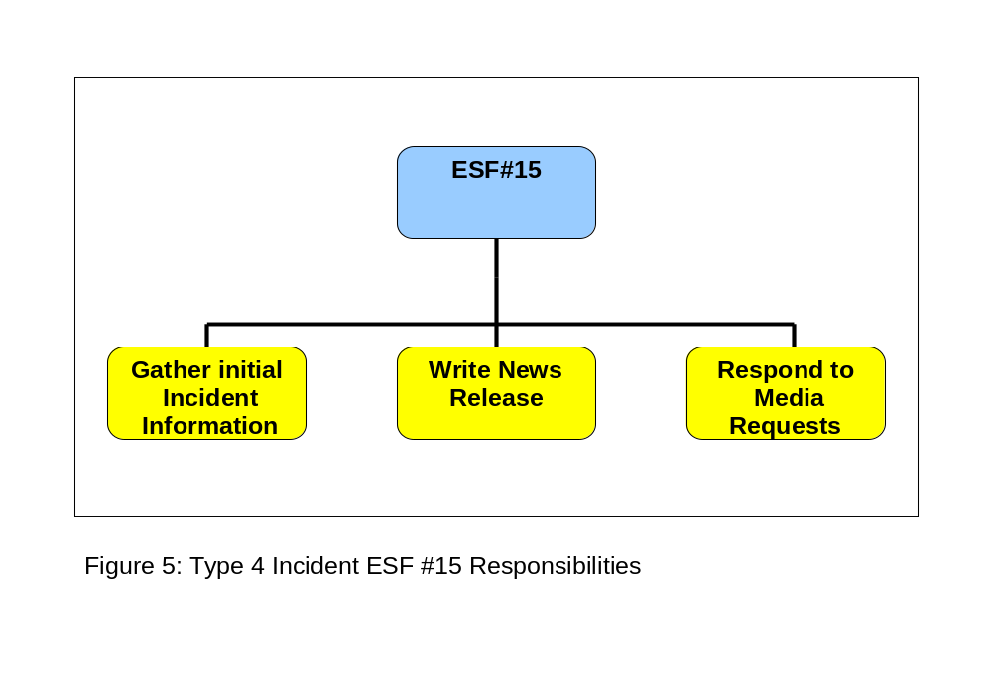
      - Type 3 Incident (Major local incident or moderate incident involving more than one county / Partial JIC Activation)
- Incident response and local media coverage may extend into multiple operational periods of 12 hours or longer; JIC staffing may require multiple work shifts.
- Additional capabilities are needed and the JIC expands to include branches.
- ESF #15 may coordinate with local PIOs to assist the local jurisdiction with information management. Rural jurisdictions may utilize the State JIC to provide the jurisdiction with direct PIO support.
- Examples include a plant explosion, train derailment, school shooting, or flooding.
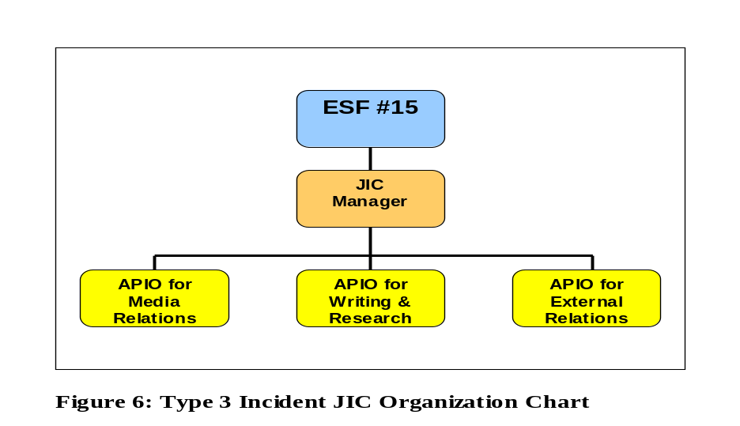

      - Type 2 Incident (Major State incident which includes multiple jurisdictions, full JIC activation)
- Incident response and state/regional media coverage may last multiple days or weeks; JIC staffing will require multiple work shifts and staff replacements.
- Response personnel from other counties, regions, state or national organizations arrive to supplement local city/county resources.
- May result in a presidential disaster declaration.
- Local jurisdiction information management resources may become overwhelmed and need additional support to coordinate public information.
- Examples include a multi-county earthquake, flood or wildfire.
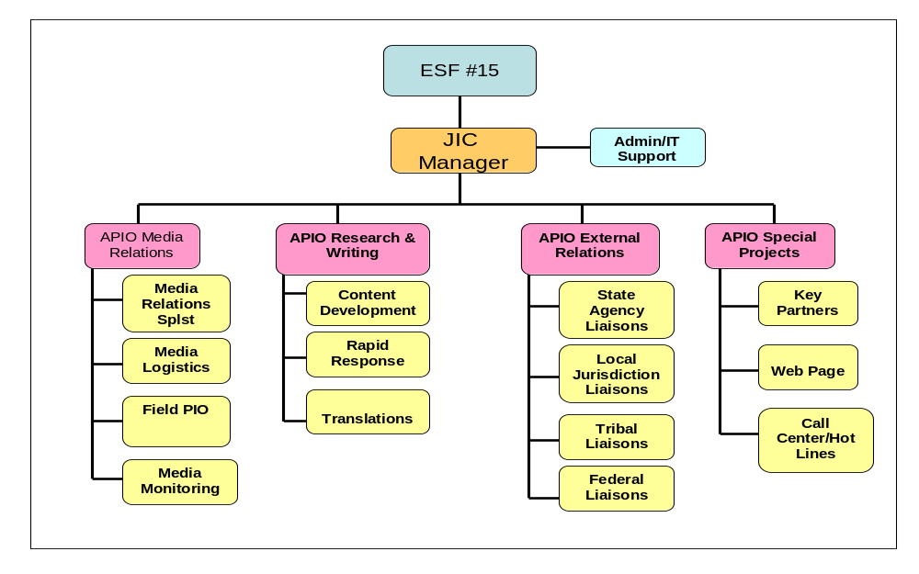
Figure 7: Type 2 Incident JIC Organization Chart

      - Type 1 Incident (Incident of National Significance / Full JIC Activation)
- Incident response and national media coverage will last multiple weeks or months.
- Response will exhaust state resources; many federal and other state resources will be employed.
- Unified Coordination Group with a Unified State/Federal JIC will be employed.
- Public information requirements and media attention will be intense and require a more robust joint information organization to support the needs of the afflicted jurisdictions.
- Examples include a major terrorist attack, major earth quake or national pandemic
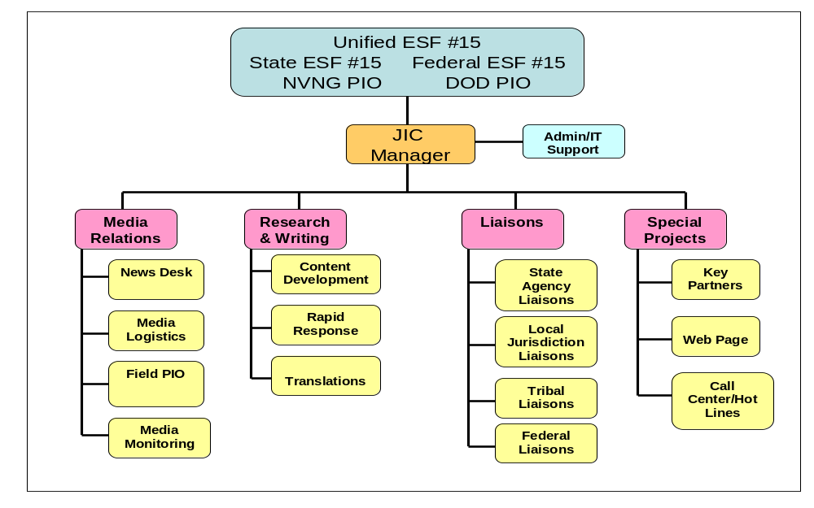
Figure 8: Type 1 Incident JIC Organization Chart

    - JIC Lay Out
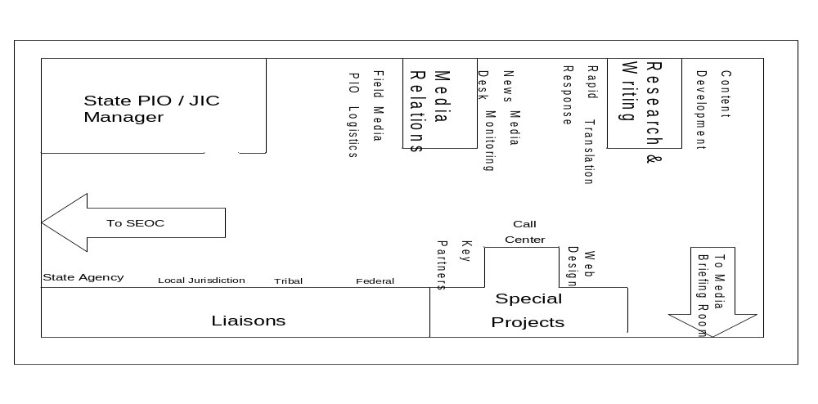Figure 9: State JIC Layout

    - Demobilization
The State JIC will demobilize in a phased manner as directed by ESF #15 when dictated by the conditions of the incident. Prior to demobilization the JIC manager must ensure that all JIC equipment and supplies are restocked to ensure that the JIC is ready when called again. See Annex A, Job Aid 3: JIC Demobilization Checklist.

  - Key Roles and Responsibilities

    - Command Positions

      - ESF #15
ESF #15 is responsible for developing and releasing public information about the incident to the media, incident personnel and other appropriate agencies and organizations as approved through the proper channels.
ESF #15 may appoint as many assistants as necessary, and the assistants may also represent assisting agencies, jurisdictions or other response partners (such as private sector and non-governmental organizations).
ESF #15 is appointed by the SEOC Manager or the GPS to support the information needs of the response; establish, maintain and deactivate the JIC; and represent and advise the SEOC Manager or the GPS on all public information matters relating to the incident.

ESF #15 Responsibilities:
- Support public information needs of the SEOC or GPS. (See Daily Checklist in Appendix D.)
- Obtain approval from SEOC or GPS to disseminate public information products.
- Advise Command on public information issues and concerns.
- Attend all Command Staff briefings and meetings. (See Operational Planning “P” in Annex D)
- Share information gathered at Command Staff briefings and meetings with JIC Staff.
- Work closely with the Liaison Officer (LNO), Safety Officer (SO) and Intelligence Officer (INTO).
- Coordinate operational mission assignments with the JIC Manager.
- Establish and equip the State JIC and oversee its operations.
- Respond to the local jurisdiction’s public information support requests.
- Gather incident information.
- Inform the media and public.
- Provide public information to incident staff.
- Monitor the media, correct misinformation and identify trends and issues.
- Analyze public perceptions and develop public information strategies.
Position Specific Functions

Establishing a JIC
When the appointed ESF #15 and briefed by the SEOC manager, several actions must be taken to establish and manage a JIC. To assist in establishing and managing a JIC, Job Aid 2 - Establishing a JIC can be found in Annex A.
Establishing a 24-hour Schedule
If demands are high, a 24-hour operating schedule may require multiple shifts, such as:
- A Shift: 5am to 6pm.
- B Shift: 5pm to 6am.
The one-hour overlap in each 13-hour shift provides time for briefing and transition, and meets most major media deadlines.
In the event a 24-hour schedule is required, an Assistant ESF #15 will be assigned to perform the ESF #15 responsibilities when he or she is not present. The Assistant ESF #15 has all of the responsibility and authority of the ESF #15.
Exchanging Information
Information Exchange Matrix 1 – for Public Information Officers can be found in Appendix B. This information exchange matrix describes what types of information or resources the PIO should obtain from specific response positions within the ICS organization, as well as what information or resources the ESF #15 should provide to those same positions.

Working with the Safety Officer (SO), Liaison Officer (LO) and Intelligence Officer (INTO)
ESF #15 meets regularly with the SO, LNO and INTO. The SO’s main responsibility is to monitor safety conditions and develop measures for assuring the safety of all incident personnel. ESF #15 works with the SO to develop safety messages and escort media and VIPs to the incident site in a safe manner.
ESF #15 PIO works with the LNO to obtain and provide information to agency representatives, public officials and other stakeholders. ESF #15 also works with the LNO to address stakeholder concerns, requests for briefings, tours and VIP visits.
The SEOC Manager may appoint an INTO as the incident requires. The INTO’s main responsibility is to supervise, coordinate and participate in the collection, analysis, processing and dissemination of intelligence. ESF #15 works with the INTO regarding intelligence information and operational security. Depending on circumstances surrounding each incident the INTO may become a function within the General Staff as a technical specialist within the Operations Section or Planning Section, or as its own Section2.
Demobilizing a JIC
The SEOC Manager determines when to deactivate the JIC based on the recommendation of ESF #15. This decision would usually be made when media and public interest has diminished or when recovery and mitigation operations are complete. To assist ESF #15 with demobilization activities, Job Aid 3 - Demobilizing a JIC can be found in Annex A.

      - Assistant PIO/ JIC Manager
The APIO/JIC Manager is selected by ESF #15 to supervise the daily operations of the JIC; execute plans and policies, as directed by ESF #15; and provide direction to the APIOs to ensure that all functions are well organized and operating efficiently. The APIO/JIC Manager should possess public affairs, crisis response, JIC and management or leadership experience. The APIO/JIC Manager should have the same training as ESF #15.
APO JIC Manager Responsibilities
- Assume all responsibilities of ESF #15, as needed.
- Supervise all JIC operational and administrative activities.
- Ensure proper organization of JIC.
- Oversee all operations of the JIC.
- Coordinate internal JIC information flow.
- Set JIC staff work hours and daily operating schedule.
- Maintain unit log. (See ICS Form 214 in Appendix C)
- Respond to the local jurisdiction’s public information support requests.
- Advise ESF #15 and IC/UC about recommended public information strategies.
- Assess and assign JIC staff to appropriate roles. (See JIC Staff Self-Assessment Survey in Appendix D)
- Provide training or coaching to JIC staff as needed.
- Coordinate with Logistics Section Chief (LSC) to obtain equipment, supplies and other resources for the JIC.

Developing the Operating Schedule
The APIO JIC Manager manages the JIC staff by developing an operating schedule. To assist the APIO JIC Manager in developing an operating schedule, Job Aid 4 – Developing the Operating Schedule can be found in Appendix A. The Daily Brief Worksheet is a useful tool when developing the operating schedule (Appendix D) as well as ICS Form 204 (Appendix C).

      - Administrative Support/ IT
The Administrative / IT Support Unit reports to and take direction from the JIC Manager and/or ESF #15 to provide administrative and clerical support for JIC operations during an emergency event. Additionally, this unit is responsible for obtaining and maintaining all documentation records including operational files and communication materials, as well as providing or coordinating IT support to units.

Roles and Responsibilities
- Assists ESF #15 and JIC Manager in providing overall admin and clerical support for JIC operations
- Submits requests to the EOC logistics section to secure the necessary JIC equipment, infrastructure and office supplies needed for JIC operations
- Assists JIC Manager in contacting JIC partners and PIOs to staff JIC
- Serves as a scribe to update verified information on status boards
- Serves as the documentation unit for JIC operations and maintains records, paperwork and files and copies of all versions of communications materials
- Assists with answering main JIC lines and routing them to appropriate unit leads, take messages, and return calls as directed by JIC manager
- Submits requests to the EOC logistics sections for water, food and other supplies for staff
- Works with IT support to provide technical support for JIC units as needed
- Assists with distributing final approved materials to JIC units
- Assist with clerical and word processing tasks as requested by JIC Manager
- Serves as a runner and handles issues as they arrives

    - Media Relations Branch

      - Assistant PIO for Media Relations

The APIO for Media Relations is assigned by ESF #15 or APIO/JIC Manager to coordinate the release of information to the media.
Personnel selected for this position should possess experience in public information, crisis response, JIC operations, management and ICS, as well as have demonstrated skills in interacting with the media.
Responsibilities
- Respond to media inquiries.
- Select and prepare speakers prior to interviews.
- Conduct news briefings and interviews.
- Provide escorts to the media.
- Credential media.
- Maintain multi-lingual capabilities, if necessary.
- Maintain and update media lists.
- Identify misinformation or rumors.

4.3.2.2. Media Relations Specialist
The Media Relations Specialist is assigned by the APIO/JIC Manager to manage the distribution of information regarding the event. Personnel selected for this position should have experience interacting directly with the media, be able to speak clearly and concisely, be able to accomplish tasks with minimal direction and function efficiently in a high-stress environment. Depending on the region, bilingual personnel may be needed in this unit.

Media Relations Specialist Responsibilities
- Determine primary media outlets.
- Produce detailed accounts of calls, including name and organization, phone number, nature of inquiry and result. (See Query Record, Appendix D.)
- Maintain a comprehensive and current media list containing points of contact, phone, pager, cellular and fax numbers and e-mail and postal addresses.
- Disseminate approved written material to the media.
- Staff the phones with people able to answer calls, possibly in more than one language, from local, state, national and international media.
- Respond to routine inquiries using talking points, speaker preparation, news releases and fact sheets.
- Promote story and feature ideas to target media.
- Establish a daily drive-time call-out schedule that meets local radio and television deadlines. This will vary with each incident.
- Document the time and details of the response; track inquiries to ensure response and closure within a timely manner (ideally, less than one hour).

      - Media Logistics
The Media Logistics Specialist is assigned by the APIO/JIC Manager to manage the coordination of meetings, interviews and engagements. The Media Logistics Specialist reports to the APIO for Media Relations. Personnel selected for this position should have good interpersonal skills, the ability to accomplish tasks with minimal direction and function efficiently in a high-stress environment. In addition, personnel may need to be bilingual.
Media Logistics Specialist Responsibilities
- Identify, schedule and prepare appropriate personnel and subject matter experts for news briefings and media interviews.
- Advise ESF #15 and APIO/JIC Manager on times for news briefings.
- Coordinate with the Administrative Assistant about set-up and audiovisual needs for news briefings and media interviews.
- Schedule and coordinate editorial board.
- Notify National Guard Security for media access to the Base.
Position Specific Functions
Speaker Preparation
The Media Logistics Specialist should prepare personnel for speaking to the general public and media during phone interviews, on-camera interviews and news briefings. See the Speaker Preparation Worksheet in Appendix D.
Media Briefings
The Media Logistics Specialist should identify spokespersons for scheduled media briefings. (See Spokesperson Request Worksheet, Appendix D.) When setting up and conducting media briefings, refer to the Media Briefing Worksheet in Appendix D. Personnel from nearly all positions in the JIC will play some part in this process.
Editorial Board
An Editorial Board is a meeting between the SEOC Manager and an editor from a media organization in which reporters may or may not be present. Usually an Editorial Board meeting is not conducted until several days into an incident, but may need to occur sooner based on the needs of the incident. The Editorial Board meeting serves the following functions:
- Provides the SEOC Manager a chance to explain in broad terms the policies and positions of the command.
- Provides the editor with a chance to ask questions about SEOC Manager policies and positions as they pertain to the response.
- Is normally held in the offices of the editor and typically does not result in a story; it is intended to be used for background in future stories.

      - Field PIO
The Field PIO is assigned by the APIO/JIC Manager to assist local PIOs with public information messaging, assist with the coordination media relations and other areas of support in the field. Depending on the region, bilingual personnel may be needed.

Field PIO Responsibilities
- Ensure media are properly equipped and informed. (See Field Escort Equipment and Communications Checklist in Appendix D.)
- Escort media to incident scene or other field locations.

Based on the needs of the incident, the Field PIO may be assigned additional responsibilities, such as:
- Take photos and video of incident scene.
- Gather facts from incident scene.
- Disseminate approved incident information to members of the media and public.

      - Media Monitoring and Analysis
The Media Monitoring and Analysis Specialist assess the content and accuracy of news media reports and assists in identifying trends and breaking issues.
The Media Monitoring and Analysis Specialist provide daily coverage synopses; identifies issues, inaccuracies and view points; and recommends corrections to the APIO for Media Relations.
Media Monitoring and Analysis Specialist Responsibilities
- Determine newspaper, radio, television and internet outlets to monitor.
- Monitor blogs and social networking sites.
- Gather perceptions from the media, public and other stakeholders about the progress of the response efforts.
- Identify potential detrimental rumors and rapidly determine effective ways to deal with them or pass to Rumor Control, if an individual or group of individuals has been designated to process rumors.
- Set up a news clip collection (radio, TV, print and appropriate Internet websites). Request Finance Section to contract a broadcast media monitoring and print clipping service, or set up equipment to record radio and television news and/or to print media websites and blogs.

Analyzing Information
The Media Monitoring and Analysis Specialist will monitor and analyze the media coverage of the response (The Media Analysis Worksheet and Media/Social Media Worksheet can be used for analyzing and identifying potential solutions for media coverage that does not support Best Response and is located in Appendix D.) When appropriate, the Media Monitoring and Analysis Specialist will make recommendations to improve or increase the coverage and accuracy of information in an effort to alleviate concerns and gain community support.

The major activities involved in analyzing information are:
- Track incoming phone calls and requests.
- Determine media outlets that reach significant diverse audiences.
- Identify potential issues, problems and rumors and report the information immediately to ESF #15 and appropriate agency or office.
- Identify significant diverse communities and determine the most effective ways to communicate with them (e.g., media, fliers, posters and town meetings).
- Monitor the perceptions of the affected communities concerning the progress of the response.
- Make a record of each print, broadcast and Internet news clip (including a summary of coverage, issues, inaccuracies and view points) using the Media Analysis Worksheet and Media and Social/Media Worksheet. (See Appendix D.)

    - Research and Writing Branch
      - APIO for Research and Writing
The APIO for Research and Writing is assigned by the ESF #15 or APIO/JIC Manager to manage the product development responsibilities of the JIC. Personnel selected for this position should possess some public information, journalism, photography, videography, web management, desktop publishing, ICS and JIC experience. Selected personnel should be able to type, operate a variety of computers and software, work quickly, accomplish tasks with minimal direction and function efficiently in a high-stress environment.
APIO for Research and Writing Responsibilities
- Produce written news releases, media advisories, public service announcements, fact sheets and other publications.
- Route to ESF #15 for approval all documents, photos, video and other materials (accurate information is essential in preventing public confusion, loss of credibility and/or adverse publicity).
- Establish and manage an incident news website.
- Take and disseminate news photos and video of the incident.
- Produce and gather graphics and logos for the incident.
- Produce incident timeline and casebook.

      - Content Development Specialist
The Content Development Specialist is assigned by the APIO for Information Products to produce written news releases, media advisories, public service announcements, fact sheets, talking points, emergency public information, voice and text messages, blog and social media statements and other direct-to-stakeholder information products. Personnel selected for this position should possess strong journalism skills and some public information, ICS and JIC experience.
Content Development Specialist Responsibilities
- Reviews information provided by Information Gathering
- Uses templates to draft media advisories, news releases, and other products
- Obtains approval from ESF #15 and SEOC Manager before distribution
- Routes approved documents to Website Specialist and Information Communication
Position Specific Functions
Writing a News Release
The Content Development Specialist should draft and gain approval of a written news release. See Writing Guidelines for News Releases in Appendix D for instructions on how to write a news release. Also refer to Appendix D for a Sample News Release.

      - Rapid Response Specialist
The Rapid Response Specialist receives, verifies and ensures facts are disseminated to dispel incorrect rumors regarding the incident.
Rapid Response Specialist Responsibilities
- Identify and report any rumors that may cause issues or problems to the APIO for Information Gathering, APIO for Media Relations and APIO for Community Relations.
- Verify the accuracy of the rumor and document results on JIC Rumor Control form.
- Report results of each rumor investigation to previously noted APIOs.
- Maintain a file of JIC Rumor Control forms. (See Query Record, Appendix D). ICS Form 213 in Appendix C can also be used to record rumors that are reported to the JIC.

      - Translation Specialist
The Translation Specialist coordinates releases with the Spanish speaking media and provides content for translation services to translate into other languages. Personnel selected for this position should be bilingual in English and Spanish and possess strong journalism skills in Spanish.

Translation Specialist Responsibilities
- Coordinate releases for non- English speaking media.
- Coordinate materials to be translated through state translation services.
- Ensure all speakers have sign language interpreters for briefings.

    - External Relations Branch

      - APIO for External Relations
The APIO for External Relations is assigned by the State PIO/JIC Manager to monitor the community’s concerns regarding the incident, advise the PIO about community information needs, and coordinate release of information to the public.
Personnel selected for this position should possess community relations, crisis response, JIC, operations, management and ICS experience, as well as have demonstrated skills in interacting with the public. Personnel should have experience identifying different publics/stakeholders, and using interviews to ascertain community knowledge, attitudes and behaviors.
Responsibilities
- Coordinate with local jurisdiction PIOs to determine the information needs of the community.
- Assist the local jurisdiction to develop and coordinate community outreach programs.
- Establish contact with influential local community members that can provide feedback about how the response is perceived.
- Determine the need for and format of community meetings.
- Conduct and/or participate in community meetings.
- Canvass the local community for feedback and to disseminate incident information. (See Opening Statement for Community Relations Interviews in Appendix D).
- Develop posters, fliers, newsletters and other community outreach materials.
- Inform the public of volunteer opportunities coordinated by the LNO and assisting agencies.
- Respond to community inquiries.

      - Local Jurisdiction Liaisons
The Local Jurisdiction Liaison is assigned by the APIO/JIC Manager to document and respond to community inquiries. Personnel should have experience identifying different publics/stakeholders, and using interviews to ascertain community knowledge, attitudes and behaviors. Depending on the region, multilingual personnel may be needed in this unit.
Local Jurisdiction Liaison Responsibilities
- Identify communities affected by the incident.
- Produce detailed accounts of calls, including name and organization, phone numbers, nature of inquiry and results.
- Determine how well community members comprehend command objectives/messages and make recommendations for corrective actions through the APIO for Community Relations.
- Determine community attitudes toward the incident and response organization and recommend actions to encourage/change those attitudes, as necessary.
- Determine community behaviors related to the incident situation and recommend actions to encourage protective or corrective behavior.
- In conjunction with the LNO, maintain a comprehensive and current list of interested stakeholders, including phone and fax numbers or e-mail addresses.
- Disseminate approved written material to the community.
- Staff the phones with people able to answer calls, possibly in more than one language, from the community.
- Respond to routine inquiries using talking points, frequently asked questions, news releases, fact sheets and other community relations materials.
- Route inquiries about volunteer opportunities to the Volunteer Coordinator, LNO, or LSC.

      - State Agency Liaisons
The State Agency Liaison is assigned by the APIO/JIC Manager to coordinate information requests for specific state agencies providing incident response support. Personnel should have experience and understanding of the various roles that state agencies have in response to all hazards incidents.

State Agency Liaison Responsibilities
- Coordinate information request through the agency PIO.
- Facilitate State Agency PIO Committee meetings.

    - Special Projects Branch

      - APIO for Special Projects
The APIO for Special Projects is assigned by the ESF #15 /JIC Manager to manage the state incident information website, call center content and other projects assigned by the ESF #15 or JIC Manager. Personnel selected for this position should possess website design and call center experience.
APIO for Special Projects Responsibilities
- Develop and manage state incident information website.
- Manage call center accounts and content.
- Coordinate with key partners and subject matter experts.
- Manage other special projects as assigned.
- Coordinate with Nevada Department of Health and Human Services Aging and Disability Services Division – Emergency Response Interpreter Coordinator
- Coordinate with Nevada Governor’s Council on Development Disabilities Executive Director
- Coordinate with FEMA Region IX Disability Integration Specialist

      - Web Page Specialist
The Website Specialist is assigned by the APIO/JIC Manager to manage all JIC web activities in support of the APIO for Special Projects and his/her staff. Personnel selected for this position should be knowledgeable of website design software, internet protocols, website accessibility for special needs populations (Section 508 of the Americans with Disabilities Act of 1990); able to accomplish tasks with minimal direction; and function efficiently in a high-stress environment.
Responsibilities
- Maintain and update incident website and incident social media accounts.
- Maintain JIC blog if applicable. (Refer to Content and Writing Guidelines for Bloggers in Appendix D.)
- Route email inquiries to Media or Community Relations Specialist.
- Ensure approval of all items prior to emailing or posting on the incident website.
- Ensure all items posted to the incident website are Section 508 compliant.
- Establish a virtual JIC, as needed.
- Maintain social media platforms
- Coordinate with web support personnel for all agencies represented in organization to ensure site meets individual agency requirements.
- Coordinate media and community distribution lists.

The SEOC Manager should designate one official website to represent the response efforts, provide answers to the public’s questions and address issues raised through other media sources. After a case is closed and the JIC demobilizes, the State PIO should consider monitoring continued interest and keeping the website on-line longer than a few months.
Responders should monitor the information being posted on other websites, blogs, chat rooms and social media platforms. Questions, concerns or misinformation found on other websites, blogs and chat rooms should be addressed on the official website.

      - Call Centers/Hot Lines Specialist
The Call Centers/Hot Line Specialist is assigned by the APIO/JIC Manager to manage all JIC call center / hot line activities in support of the APIO for Special Projects and his/her staff. Personnel selected for this position should be knowledgeable of call center operation, contracts established for call centers or hotlines such as the Nevada 211 system, and call center protocols.

- Maintain and update the Nevada 211 system for the incident.
- Coordinate with other local, federal and NGO call centers.
- Ensure approval of all items of scripted information prior to release to the call center.
- As necessary order from Logistics and assign call takers.
- Coordinate with Nevada Department of Health and Human Services Aging and Disability Services Division – Emergency Response Interpreter Coordinator

- Coordination
  - Governor Activation of the JIC for Administrative Purposes
If the JIC is activated by the Governor’s Press Secretary (GPS) for the purposes of distributing important administrative information for the state, the Governor’s policy directions and messages will be conveyed through the GPS to the ESF #15 or lead agency PIO and managed through the JIC.

  - SEOC Activation of the JIC in Response to an Incident
JIC operations for State incident response take precedence to the activation of the JIC by the Governor although the Governor’s messages may be coordinated by the JIC through the SEOC Manager. During an incident response the JIC is a component of ESF #15 of the SEOC Operations Section. The State PIO is a member of the SEOC command staff and reports to the SEOC Manager.

- Plan Maintenance
The DPS/DEM PIO is responsible for the maintenance, update and dissemination of this OPLAN. The DPS/DEM PIO will work with the JIC working group to evaluate the OPLAN annually and modify the plan to adhere with changes in state policies and procedures; and after action reports and lessons learned from JIC activations for incidents or exercises.

- Training and Exercise
The DPS/DEM PIO is responsible for training prospective JIC staff on this OPLAN and shall exercise the OPLAN at least every year in a JIC specific exercise or an exercise involving the activation of the SEOC. At the conclusion of each exercise an after action report and an improvement plan shall be developed and the OPLAN may be modified to reflect the lessons learned from the exercises.

- Annexes
Annex A: Job Aids
Annex B: Job Action Sheets
Annex C: Forms
Annex D: References, Worksheets and Samples
Annex E: Acronyms

JOB AID 1 – ESTABLISHING THE INITIAL RESPONSE

STEP | ACTION
1. | Check in and obtain initial briefing from SEOC Manager.
2. | Establish a dedicated phone line and website for providing information and managing telephone and e-mail inquiries from the media, stakeholders and general public.
3. | Establish a dedicated phone line and website for providing information and managing telephone and e-mail inquiries from the media, stakeholders and general public.
4. | Use gathered facts to answer inquiries.
5. | Activate the following positions as needed:  Media Relations Specialist  1. Use dedicated phone to answer calls from media, stakeholders and public.  2. Record names, phone numbers and organization of the callers; also note date/time of calls, nature of inquiries and deadlines for receiving additional information. (See Query Record in Appendix D.)  3. Use approved news releases and gathered facts to answer media calls. (See Sample Documents in Appendix D.)  Rapid Response Specialist  1. Gather verified incident information from sources throughout the response organization. (See ICS Form 209 in Appendix C.)  2. Provide this information to the assistants handling inquiries and writing news releases.  Content Development Specialist  1. Assemble gathered facts into two or three sentences that answer who, what, when, where, why and how of incident. (See Sample Documents in Appendix D.) NOTE: Answering the “why” and “how” at many incidents is difficult or impossible to accomplish (e.g., these facts may only come out after an investigation).  2. List remaining facts and information in bullet form. (List responding agencies, type and amount of equipment, etc.)  NOTE: News releases should be only one page in length. If there is a need for additional information about specific topics, then a separate fact sheet should be made.  3. Spell check and edit news releases and give to PIO for editing, approval and routing to the IC for final approval.  4. Give approved news releases to Media Relations Assistant.  5. Distribute news releases to news media and other requestors.  6. Develop three key messages as soon as information is gathered.
6. | Call for more assistance, preferably people trained in public information, JIC and ICS operations. Make requests for additional resources via the Logistics Section.

JOB AID 2 – ESTABLISHING a JIC

STEP | ACTION
1. | Conduct transition meeting with initial SEOC Manager.
2. | Appoint someone experienced as APIO/JIC Manager.
3. | Appoint someone experienced as APIO for Media Relations
4. | Appoint someone experienced as APIO for Research and Writing
5. | Appoint someone experienced as APIO for External Relations
6. | Appoint someone experienced as APIO for Special Projects.
7. | Use the Nevada Joint Information OPLAN to ensure all PIO responsibilities are being performed  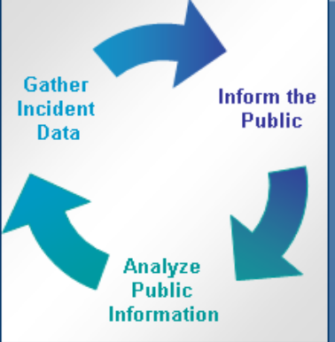

JOB AID 3 – Demobilizing a JIC

STEP | ACTION
1. | Receive Demobilization Plan from Planning Section Chief (PSC) or Demobilization Unit Leader.
2. | Brief personnel regarding demobilization.  Debrief appropriate personnel prior to departing incident:  - SEOC Manager  - PSC  - LSC  - Agency representatives
3. | Supervise demobilization of unit, including inventory, return and storage of equipment and supplies.
4. | Forward all Section/Unit documentation to PSC or Documentation Unit Leader.
5. | Supervisors to complete Incident Personnel Performance Rating (ICS 225); all individuals complete Check-out Sheet
6. | Notify media and other stakeholders when JIC will demobilize, whether virtual JIC website will continue to be updated and which agency or organization PIOs to contact for any future inquiries or updates.

JOB AID 4 – Developing the Operating Schedule

STEP | ACTION
1. | Conduct transition briefing between shifts. (See Daily JIC Brief Worksheet, Appendix D.)
2. | Review Self-Assessment Survey completed by new JIC staff members and assign to appropriate roles and work hours.
3. | Coordinate with PSC regarding Daily Meeting Schedule (ICS Form 204) of Command and General Staff briefings and meetings.
4. | Coordinate with the APIO for Information Products to set deadlines for writing, approval and dissemination of all information products.
5. | Coordinate with the APIO for Media Relations and Speaker Support Specialist to set the schedule of media briefings, community meetings, media/VIP tours and other JIC events, including deadlines for speaker preparation.
6. | Gather Command Message(s) for the APIO for Information Products from the PIO and UC.
7. | Coordinate with ESF #15 and JIC staff on messages and strategies for reaching target audiences.
8. | Deliver media analysis to ESF #15.
9. | Ensure preparation for news briefings.

JOB AID 5 – Producing the Status Board

STEP | ACTION
1. | Contact PSC or Situation Unit Leader to obtain latest ICS Form 209 Status Summary.
2. | Meet with key response positions and post obtained information in the JIC.
3. | Display current news releases, fact sheets and incident news clips in physical JIC on status board or data projectors and/or in virtual JIC website for Command and JIC staff to view.
4. | Display non-incident/morale boosters – other news, sports, comics, local restaurant menus, etc.
5. | Coordinate with Planning Section’s Display Process to identify high-traffic locations for status boards in the SEOC visible to other ESFs.
6. | Update boards as needed, including after each Operations Briefing.

JOB AID 6 – Validating Rumors

STEP | ACTION
1. | The Rapid Response Specialist receives rumor from someone in other response position (e.g., Media Relations Specialist or Community Relations Specialist).  NOTE: Rumors can be received by anyone from many different means – by field workers through interaction with the public, by other JIC members who work with the media, etc. Intake of rumors to the JIC may be via telephone, face-to-face interaction, via ICS Form 213 General Message and any other means.
2. | The Rapid Response Specialist documents received rumor and all amplifying information on JIC Query Record (See Appendix D).
3. | The Rapid Response Specialist seeks out appropriate response organization subject matter expert to validate/invalidate received rumor (e.g., Situation Unit Leader (SITL) for collected incident data or LNO for list of assisting agencies).
4. | The Rapid Response Specialist records validated fact on Rumor Query Record.
5. | The Rapid Response Specialist provides copies of completed form to the following JIC personnel:  - APIO for Research and Writing (to correct any previously released or draft information products, to correct any information posted to incident website and for filing in JIC records);  - APIO for Media Relations (for dissemination to the media); and  - APIO for External Relations (for dissemination to the public).

JOB AID 7 – Providing Media Briefing

STEP | ACTION
1. | Secure a space for the event.
2. | Provide and set up chairs, tables and lectern.
3. | Set up microphone and public address system, if necessary.
4. | Set up supporting graphic material near spokespersons.
5. | Set up overhead projector, televisions/VCRs and/or computers for supporting visuals.
6. | Ensure State logo is prominently displayed

This page is intentionally left blank

Emergency Support Function (ESF) #15 –
Public Information/External Affairs

Mission: The ESF #15 is responsible for directing and managing the overall JIC operations and providing prompt and organized responses to the news media as well as coordinating all public information efforts out of JIC.

Date: _______ Start: _______ End: _______ Position to Report to: ________________________

Signature: _______________________________________________ Initial: _______________

Fax:____________________

Telephone: _____________Cell/Pager: ____________Email: ____________________________

Immediate (Operational Period 0-2 Hours) | Time | Initial
Report to the SEOC and receive appointment from SEOC Manager.
Read this entire job action sheet, review EOC and JIC org charts and put on vest.
Obtain situational briefing from SEOC Manager.
Establish JIC and contact agencies involved to send a representative to JIC.
Review initial objectives with SEOC Manager, including deadlines.
Develop message objectives and identify restrictions in content of news release and public information from SEOC Manager.
Assign and Instruct JIC Manager to call down PIO staff, make assignments and complete JIC staff org chart.
Intermediate (Operational Period 2-12 Hours) | Time | Initial
Attend meetings with SEOC command team and report information back to JIC. Instruct JIC Manager to oversee/ manage JIC operations while in SEOC meetings/briefings.
Ensure all information for release has been verified. Obtain approval from the SEOC Manager.
Review and approve all final media and public information developed by JIC Unit Leads before public release/distribution.
Obtain regular briefings and situational reports from JIC Manager and/or JIC Unit Leads and identify solutions to key issues or challenges.
Establish frequency of the release of information and/or media briefing sessions.
Determine interval for next release of information to the media.
Document all JIC activities and messages received, including other key information such as media logs, special contacts, decisions made and actions taken etc.
Document and keep records of all of media and public information materials.
Extended (Operational Period Beyond 12 Hours) | Time | Initial
Assess media and public information needs during a prolonged event.
Continue to receive regular briefings from JIC Manager and Unit Leads.
Continue to attend SEOC command team meetings/ briefings as needed.
Continue to verify and approve all information for public release.
Observe all JIC PIO staffing for signs of stress or atypical behavior and make reassignments as necessary.
At shift change, provide detailed status report and written materials to replacement staff.
Evaluate JIC operations with JIC Unit Leads and staff.
Demobilization/System Recovery | Time | Initial
As need for media response decreases, ensure that JIC PIO staff return to their normal jobs by combining or deactivating positions.
Instruct JIC Manager to assist in deactivation procedures and ensure proper shut-off or return of all equipment and supplies, including all assigned incident command equipment.
Coordinate release of final media briefings and reports.
Brief Incident Commander on current problems, outstanding issues, and follow-up requirements.
Prepare final status reports upon deactivation of position.
Collect and document observations, lessons learned and recommendations for improvements for possible inclusion in the After Action Report.
Participate in after-action debriefings.
Conduct Post-event Evaluation.
Document/Tools
- Nevada Joint Information OPLAN
- Supplemental background info/ materials.
- Jump drives with JIC and Risk Communication Documents
- JIC staff org chart, Job Action Sheets, & Roles/Responsibilities list
- PIO call-down lists
- DEOC/EOC/ HICS communications directories
- EOC Org Charts
- Key Contact Lists
- Field Maps

JIC – JIC Manager

Mission: The JIC Manager is responsible for overseeing the operations of the JIC and staff. This includes oversight of functional units and ensuring information is shared among units. The JIC manager is also charged with managing the JIC and acts as ESF #15 when the ESF #15 attends SEOC command briefings.

Date: _________ Start: _________ End: ________ Position to Report to: ___________________

Signature: _______________________________________________ Initial: _______________

Fax:______________________

Telephone: _____________Cell/Pager: _______________Email: ________________________

Immediate (Operational Period 0-2 Hours) | Time | Initial
Receive appointment/instruction from the ESF #15.
Obtain situational briefing from ESF #15.
Read this entire job action sheet, review JIC Org Chart and put on vest.
Review JIC operations objectives with ESF #15, including deadlines.
Assist ESF #15with staff call down list, making assignments and completing the JIC
Org Chart.
Assign Admin Support staff to support JIC and assist with JIC set up and workstations.
Instruct Admin support to hand out RC material packets, preloaded flash drives, etc.
Post important key contact numbers and relevant operational information on white
boards, etc.
Support ESF #15 by maintaining managerial oversight of JIC Unit Leads and operations.
Provide guidance and support to JIC Unit Leads on roles and responsibilities.
Obtain regular reports from each JIC Unit Lead to report back to ESF #15.
In the absence of the ESF #15, hold briefings with all JIC Unit Leads and staff approximately every 20 minutes.
Ensure that Admin/ IT Support unit assigns scribe to capture all crucial information that has been verified or updated on status boards.
Intermediate (Operational Period 2-12 Hours) | Time | Initial
Support ESF #15 by maintaining managerial oversight of JIC Unit Leads and operations.
Manage and oversee JIC while ESF #15 is in meetings/ briefings.
Clarify issues with ESF #15 and provide direction to staff as needed.
Assess flow of operations and determine if staff reassignments need to be made based upon unit productivity and effectiveness.
Obtain regular reports from each JIC Unit Lead and provide all reports to ESF #15.
Determine additional public informational needs based upon main JIC Unit Leads, rapid
response unit, etc.
Extended (Operational Period Beyond 12 Hours) | Time | Initial
Assess JIC operational needs during a prolonged event.
Continue to obtain verified information and provide updated briefings to ESF #15 and Staff if necessary.
Continue to receive updates from each JIC Unit Lead and report back to JIC ESF #15 if necessary.
Evaluate the effectiveness of information distribution and consider less traditional methods if needed.
Continue to assess operations flow and determine if staff reassignments are necessary.
Ensure physical readiness through proper nutrition, water intake, rest, and stress management techniques for all staff.
Observe JIC staff for signs of stress or atypical behavior. Make reassignments as necessary and notify the ESF #15.
Continue to review informational reports as needed.
Document activities and provide reports to ESF #15.
At shift change, provide detailed status report and written materials to replacement staff.
Evaluate JIC operations.
Demobilization/System Recovery | Time | Initial
As need for media response decreases, ensure that JIC operations staff return to their normal jobs by combining or deactivating positions.
Instruct Admin/ IT Support to assist in deactivation procedures and ensure return of all equipment and supplies, including all assigned incident command equipment.
Coordinate release of final briefings and reports from each JIC unit.
Brief ESF #15 regarding any problems, outstanding issues, and follow-up
requirements
Assist ESF #15 in preparing final status reports upon deactivation of position
Collect and document observations, lessons learned and recommendations for improvements for possible inclusion in the After Action Report.
Participate in after-action debriefings with the ESF #15 as needed.
Conduct post-event evaluation.
Document/Tools
- Crisis Emergency Risk Communications Operations Manual
- Jump drives with JIC and Risk Communication Documents
- Supplemental background info/ materials.
- PIO call-down lists
- JIC staff org chart, Job Action Sheets, & Roles/Responsibilities list
- SEOC communications directories
- SEOC Org Charts
- Key Contact Lists
- Field Maps
- Equipment and supplies list

JIC – APIO for Media Relations

Mission: The APIO for Media Relations is responsible for assessing, monitoring and managing all media needs. The APIO for Media Relations is also responsible for organizing and assigning staff to the following tasks: Media Relations Specialist, Media logistics, Field Specialist and Media Monitoring.

Date: _______ Start: _______ End: _______ Position to Report to: _______________________

Signature: ________________________________________________ Initial: _______________

Radio Title: ___________ Fax:_______________

Telephone: _________________Cell/Pager: _________________Email: __________________

Immediate (Operational Period 0-2 Hours) | Time | Initial
Receive appointment/ instruction from the ESF #15 and/or JIC Manager.
Obtain situational briefing from ESF #15 and/or JIC Manager.
Read this entire job action sheet, review JIC Org Chart and put on vest.
Review media objectives with ESF #15 and/or JIC Manager, including deadlines.
Work with ESF #15 to establish frequency of the release of information and/or media briefing sessions.
Prioritize and assign tasks and activities to work team members for Media Relations Specialist, Media Liaison, Field Specialist, and Media Logistics
Oversee work team members to ensure that tasks are carried out and review work progress.
Instruct Media Relations Specialist to establish a secured media phone and notify news media about phone line for media only.
Ensure that Media Relations Specialist promptly answers and returns all media calls and logs media calls, inquires and requests on media log. Media Relations Specialist should update and maintain media contact numbers, if necessary.
Consult with Research/Writing Unit to develop media advisories, releases, talking points, and press packet materials and obtain approvals from the ESF #15 and/or JIC Manager.
Review release of information to media with the ESF #15.
Assign and deploy Field Specialists to assist local PIOs to manage on-site media in the field, if necessary.
Prepare and provide status reports on media activities, including JIC and field operations as needed to JIC Manager and staff.
Intermediate (Operational Period 2-12 Hours) | Time | Initial
Work with ESF #15 and/or JIC Manager to assess media needs and organize resources to fulfill those needs.
Assign Media Relations Specialist to prioritize and respond to media calls, requests and inquiries with approved media statements and maintain media call log.
Ensure that the Field Specialist receives copies of all current and updated media advisories, releases, talking points, and all other public information materials that are being distributed.
Instruct Media Logistics to set up briefing area for news conferences under the direction of the ESF #15 and/or JIC Manager.
Obtain approval from the ESF #15 and/or JIC Manager to release of information to media as needed.
Instruct Media Liaison to distribute approved information to the news media, JIC unit staff, and Field Specialists via fax, email, hardcopy, press packets, etc.
Work closely with the Field Specialists to obtain and provide situational reports from the field.
Provide direction and guidance to Field Specialist on handling on-site media at field locations, including approving release of information as appropriate.
Extended (Operational Period Beyond 12 Hours) | Time | Initial
Work with ESF #15 and/or JIC Manager to assess media needs during a prolonged event and organize resources to fulfill those needs.
Instruct team members to continue to carry out tasks for Media Relations Specialist, Media Logistics, Field Specialist, and Media Monitoring as needed.
Continue to provide status reports to ESF #15 and/or JIC Manager.
Continue to provide informational updates to news media as needed.
Observe work team members for signs of stress or atypical behavior. Document and report concerns to ESF #15.
Ensure physical readiness through proper nutrition, water intake, rest, and stress
management techniques
Document media activities and media requests on log form.
At shift change, provide detailed status report and all written materials to replacement staff.
Evaluate Media Relations Unit operations.
Demobilization/System Recovery | Time | Initial
Obtain final reports and documentation from work team members to prepare final briefings.
Assist in deactivation procedures as needed.
Ensure return of all equipment and supplies, including all assigned incident command
equipment.
Document observations, lessons learned and recommendations for improvements for
possible inclusion in the After Action Report.
Brief ESF #15 and/or JIC Manager with the final status reports upon deactivation of
position.
Submit media logs, contact lists, and any other status documentation to ESF #15.
Participate in or provide information for after-action debriefings.
Conduct post-event evaluation.
Document/Tools
- Supplemental background info/ materials.
- Jump drives with JIC and Risk Communication Documents
- JIC staff org chart, Job Action Sheets, & Roles/Responsibilities lists
- SEOC communications directories
- Field Maps
- Media Contact Lists
- Access to press conference equipment and supplies

JIC - APIO for Research and Writing

Mission: The APIO for Research and Writing is responsible for overseeing the gathering of information, the verifying and updating of information, and content development that could be adapted for media materials and other communication vehicles such as Web, Call Center scripts, and other non-traditional communications. The APIO for Research and Writing is also responsible for organizing and assigning staff to the following tasks: Research/ Content Development, Rapid Response and Translations.

Date: _______ Start: _______ End: _______ Position to Report to: ______________________

Signature: ____________________________________________ Initial: _______________

Radio Title: ____________ Fax:__________________

Telephone: _____________Cell/Pager: _______________Email: _______________________

Immediate (Operational Period 0-2 Hours) | Time | Initial
Receive appointment/instruction from the ESF #15 and/or the JIC Manager.
Read this entire job action sheet, review JIC Org Chart and put on vest.
Obtain situational briefing from the ESF #15 and/or the JIC Manager.
Review initial message/content objectives with the ESF #15 and/or JIC Manager, including deadlines.
Prioritize and assign research and content/message activities to work team members.
Oversee work team members to ensure tasks are carried out for Research/ Content Development, Rapid Response and Translations.
Research and review pre-developed event-specific materials already in existence.
Research and obtain verified incident information needed.
Consult with Media Relations Branch and ESF #15 to draft content that can be used for media releases, advisories, key messages, talking points and other news media materials.
Consult with Special Project Branch and ESF #15 to draft event-specific materials such as Fact Sheets, FAQs, and content that can be modified for Key Partners, employee communications, Web, and Call Centers/Hotlines.
Obtain final approvals and sign off from the ESF #15 on all content.
Ensure that all materials are translated in appropriate languages.
Intermediate (Operational Period 2-12 Hours) | Time | Initial
Continue to check-in with the JIC unit leads for material needs and/or necessary revisions/ changes based on reports and needs.
Revise and/or create additional materials for media and public information, including key messages, talking points, fact sheets, FAQs and content for Web content and Call Center scripts.
Continue to get final approvals and sign off from the ESF #15 on all new and revised media and public materials before distribution begins.
Provide updated materials and information to other key JIC Units as necessary.
Provide status updates to ESF #15 and/or the JIC Manager.
Work with appropriate translations vendor of translations staff to ensure all public information materials are translated.
Coordinate with a printing company (State Printing Preferred) Services to get materials printed, if necessary.
Keep a file of all final approved written materials, including all pervious versions.
Evaluate the effectiveness of unit operations and make necessary adjustments.
Extended (Operational Period Beyond 12 Hours) | Time | Initial
Assess Research and Writing needs during a prolonged event.
Continue to provide updated materials and information as necessary.
Continue to provide regular status updates to ESF #15 and/or JIC Manager.
Observe work team members for signs of stress or atypical behavior. Document and report concerns to ESF #15.
Ensure physical readiness through proper nutrition, water intake, rest, and stress management techniques.
At shift change, provide detailed status report and all written materials to replacement staff.
Evaluate Research and Writing unit operations.
Demobilization/System Recovery | Time | Initial
As need for research/ writing decreases, combine or deactivate positions as necessary.
Obtain final reports and documentation from work team members to prepare final briefings.
Document observations, lessons learned and recommendations for improvements for possible inclusion in the After Action Report.
Brief ESF #15 and/or JIC Manager with the final status reports upon deactivation of positions.
Submit all final materials and any other status documentation to ESF #15 and/or JIC Manager.
Participate in or provide information for after-action debriefings as requested.
Conduct post-event evaluation.
Document/Tools
- Supplemental background info/ materials.
- Jump drives with JIC and Risk Communication Documents
- JIC staff org chart, Job Action Sheets, & Roles/Responsibilities list
- PIO call-down lists
- SEOC communications directories
- SEOC Org Charts
- Key Contact Lists
- Field Maps
- Message Map Templates and Fact Sheets

JIC – APIO for Special Projects

Mission: The Special Projects unit is responsible for handling and distributing information to non-media partners. The APIO for Special Projects is responsible for managing key partner information, employee communications, and ensuring that accurate information is posted on Web pages and Call Centers/ Hotlines.

Date: _______ Start: _______ End: _______ Position to Report to: ________________________

Signature: ________________________________________________ Initial: _______________

Radio Title: ___________ Fax:___________________

Telephone: ______________Cell/Pager: ________________Email: _______________________

Immediate (Operational Period 0-2 Hours) | Time | Initial
Receive appointment/instruction from the ESF #15 and/or the JIC Manager.
Read this entire Job Action Sheet, review JIC Org Chart and put on vest
Obtain situational briefing from the ESF #15 and/or the JIC Manager
Review initial Special Projects objectives with the ESF #15 and/or the JIC Manager, including deadlines.
Prioritize and assign tasks and activities to work team members for Key Partners, Web pages, and Call Center/Hotlines
Oversee work team members to ensure tasks are carried out.
Ensure that the appropriate technical protocols and procedures are followed for areas such as Web and Call Center/ Hotlines.
Instruct Key Partners to obtain contact list for Key Partners, PIO lists and other necessary contacts.
Consult with Research/ Writing Lead and JIC Manager to draft necessary materials for
Special Project unit.
Obtain content from the Research/Writing Lead to use for key partners, Web and Call Center/ Hotlines.
Provide status reports to JIC Manager and provide regular updates to staff.
Review release of information for all Key Partners, Web and Call Center materials with the ESF #15 for approval.
Coordinate with Nevada Department of Health and Human Services Aging and Disability Services Division – Emergency Response Interpreter Coordinator
Coordinate with Nevada Governor’s Council on Development Disabilities - Executive Director. Resource request for assistance needed.
Coordinate with FEMA Region IX Disability Integration Specialist – Resource request for assistance needed.
Intermediate (Operational Period 2-12 Hours) | Time | Initial
Work with Research and Writing Lead to obtain updated materials for Special Project
Unit.
Distribute new/ revised materials to Key Partners, Web and Call Centers/Hotlines with approval of ESF #15 and/or JIC manager. Provide updates to staff as necessary.
Respond to Key Partner requests and inquiries in a timely manner.
Assess any special population needs and ensure mechanisms are in place to address needs.
Coordinate with agency Call Centers/ hotlines to provide phone scripts for recording,
including translated scripts. Request reports of misinformation and call volumes from
Call Centers.
Coordinate with Web staff to post all public information materials on main Web sites and provide information to other emergency Web sites as needed.
Monitor communications for misinformation, rumors, etc. and report any
findings back to Rapid Response and JIC units.
Provide information to Rapid Response to correct any inaccurate or misinformation.
Work with Rapid Response and team members to distribute corrected information.
Extended (Operational Period Beyond 12 Hours)
Work with ESF #15 to assess Special Project needs during a prolonged event.
Ensure physical readiness through proper nutrition, water intake, rest, and stress
management techniques.
Observe work team members for signs of stress or atypical behavior. Document and
report concerns to ESF #15.
Continue to obtain revised and updated event-specific materials, key messages, and
news media materials as needed.
Continue to obtain and provide updated reports to Special Projects Branch as necessary.
Continue to provide regular status updates to ESF #15 and/or JIC Manager.
Document all activities and keep file of all distributed materials.
At shift change, provide detailed status report and all written materials to replacement
staff.
Evaluate Special Projects Branch operations.
Demobilization/System Recovery | Time | Initial
Assist in deactivation procedures as needed. Ensure all equipment is returned and shut
off.
Obtain final reports and documentation from work team members to prepare final
briefings.
Document observations, lessons learned and recommendations for improvements for
possible inclusion in the After Action Report.
Brief ESF #15 with the final status reports upon deactivation of position.
Submit all final materials and any other documentation to ESF #15.
Participate in or provide information for after-action debriefings as requested.
Conduct post-event evaluation.
Document/Tools
- Supplemental background info/ materials.
- Jump drives with JIC and Risk Communication Documents
- JIC staff org chart, Job Action Sheets, & Roles/Responsibilities list
- SEOC/DEOC/ HICS communications directories
- Field Maps
- Key Contact Lists

JIC – APIO for External Relations

Mission: The APIO for External Relations is to coordinate public information activities with the affected jurisdictions, state agencies responding to the incident and federal agencies assisting with incident response. The External Relations Branch monitors the communities’ concerns regarding the incident and incident response and coordinates public meetings

Date: _______ Start: _______ End: _______ Position to Report to: ________________________

Signature: ________________________________________________ Initial: _______________

Radio Title: ___________ Fax:___________________

Telephone: ______________Cell/Pager: ________________Email: _______________________

Immediate (Operational Period 0-2 Hours) | Time | Initial
Receive appointment/instruction from the ESF #15 and/or the JIC Manager.
Read this entire Job Action Sheet, review JIC Org Chart and put on vest
Obtain situational briefing from the ESF #15 and/or the JIC Manager
Review initial External Relations objectives with the ESF #15 and/or the JIC Manager, including deadlines.
Prioritize and assign tasks and activities to work team members.
Oversee work team members to ensure tasks are carried out.
Ensure that the liaisons are in contact with their assigned entities.
Instruct Key Partners to obtain contact list for Key Partners, PIO lists and other necessary contacts.
Consult with Research/ Writing Lead and JIC Manager to draft necessary materials for
Special Project unit.
Obtain content from the Research/Writing Lead to use for public meetings.
Provide status reports to JIC Manager and provide regular updates to staff.
Review release of information.

Intermediate (Operational Period 2-12 Hours) | Time | Initial
Work with Research and Writing Lead to obtain updated materials for External Relations Branch.
Distribute new/ revised materials to Liaisons.
Respond to Jurisdiction requests and inquiries in a timely manner.
Monitor public concerns and respond accordingly
Coordinate local jurisdictions to schedule public meetings
Coordinate with Web staff to post all public information materials on main Web sites and provide information to other emergency Web sites as needed.
Monitor communications for misinformation, rumors, etc. and report any
findings back to Rapid Response and JIC units.
Provide information to Rapid Response to correct any inaccurate or misinformation.
Work with Rapid Response and team members to distribute corrected information.
Extended (Operational Period Beyond 12 Hours)
Work with ESF #15 to assess External Relations needs during a prolonged event.
Ensure physical readiness through proper nutrition, water intake, rest, and stress
management techniques.
Observe work team members for signs of stress or atypical behavior. Document and
report concerns to ESF #15.
Continue to obtain revised and updated event-specific materials, key messages, and
news media materials as needed.
Continue to obtain and provide updated reports to External Relations Branch as necessary.
Continue to provide regular status updates to ESF #15 and/or JIC Manager.
Document all activities and keep file of all distributed materials.
At shift change, provide detailed status report and all written materials to replacement
staff.
Evaluate External Relations Branch operations.
Demobilization/System Recovery | Time | Initial
Assist in deactivation procedures as needed. Ensure all equipment is returned and shut
off.
Obtain final reports and documentation from work team members to prepare final
briefings.
Document observations, lessons learned and recommendations for improvements for
possible inclusion in the After Action Report.
Brief ESF #15 with the final status reports upon deactivation of position.
Submit all final materials and any other documentation to ESF #15.
Participate in or provide information for after-action debriefings as requested.
Conduct post-event evaluation.
Document/Tools
- Supplemental background info/ materials.
- Jump drives with JIC and Risk Communication Documents
- JIC staff org chart, Job Action Sheets, & Roles/Responsibilities list
- SEOC communications directories
- Field Maps
- Key Contact Lists

Activity Log (ICS 214)
1. Incident Name: |  | 2. Operational Period: Date From: Date To:  Time From: Time To:
7. Activity Log (continuation):
Date/Time | Notable Activities
8. Prepared by: Name: Position/Title: Signature:
ICS 214, Page 2 |  |  | Date/Time:

ICS-214 Activity Log

Each individual involved in a NIMS Incident Command System or Unified Command response is responsible for maintaining their own Individual Log (ICS-214A form) of major events and activities that they performed during their work shift.

For example, the individual may log the time they started and ended work, learned about a major incident event, completed assigned tasks, received approval to distribute a specific document, or conducted a major interview or news conference. Minor tasks do not need to be logged.

Enter your contact information at the top of the form. Enter the Time in the first column, then describe the event or activity. Use as many lines as needed. If you need additional pages, number each page (Page ___ of ___) at the top of the form.

At the end of each work shift, each individual submits their completed ICS-214A Log to the APIO/JIC Manager for inclusion into the JIC’s ICS-214 Unit Log. The State PIO submits the JIC’s ICS-214 Unit Log to the Planning Section’s Documentation Unit at the end of each Operational Period

ASSIGNMENT LIST (ICS 204)
1. Incident Name: |  |  | 2. Operational Period:  Date From: Date To:  Time From: Time To: |  |  |  | 3.  Branch: 1  Division: 1  Group: 1  Staging Area: 1
4. Operations Personnel: Name Contact Number(s)  Operations Section Chief:  Branch Director:  Division/Group Supervisor: |  |  |  |  |  |  | 3.  Branch: 1  Division: 1  Group: 1  Staging Area: 1
5. Resources Assigned: |  |  |  | # of  Persons |  | Contact (e.g., phone, pager, radio frequency, etc.) | Reporting Location, Special Equipment and Supplies, Remarks, Notes, Information
Resource Identifier | Leader |  |  |  |  | Contact (e.g., phone, pager, radio frequency, etc.)
6. Work Assignments:
7. Special Instructions:
8. Communications (radio and/or phone contact numbers needed for this assignment):
Name/Function Primary Contact: indicate cell, pager, or radio (frequency/system/channel
/
/
/
/
9. Prepared by: Name: Position/Title: Signature:
ICS 204 |  | IAP Page _____ |  |  | Date/Time:

ICS 204
Assignment List

Purpose. The Assignment List(s) (ICS 204) informs Division and Group supervisors of incident assignments. Once the Command and General Staffs agree to the assignments, the assignment information is given to the appropriate Divisions and Groups.

Preparation. The ICS 204 is normally prepared by the Resources Unit, using guidance from the Incident Objectives (ICS 202), Operational Planning Worksheet (ICS 215), and the Operations Section Chief. It must be approved by the Incident Commander, but may be reviewed and initialed by the Planning Section Chief and Operations Section Chief as well.

Distribution. The ICS 204 is duplicated and attached to the ICS 202 and given to all recipients as part of the Incident Action Plan (IAP). In some cases, assignments may be communicated via radio/telephone/fax. All completed original forms must be given to the Documentation Unit.

Notes:
- The ICS 204 details assignments at Division and Group levels and is part of the IAP.
- Multiple pages/copies can be used if needed.
- If additional pages are needed, use a blank ICS 204 and repaginate as needed.

Incident Status Summary (ICS 209)
*1. Incident Name: |  |  |  | 2. Incident Number:
*3. Report Version (check one box on left): |  | *4. Incident Commander(s) & Agency or Organization: |  | 5. Incident Management Organization: | *6. Incident Start Date/Time:  Date:  Time:  Time Zone:
 Initial   Update   Final | Rpt #  (if used): |  |  | 5. Incident Management Organization: | *6. Incident Start Date/Time:  Date:  Time:  Time Zone:
7. Current Incident Size or Area Involved (use unit label – e.g., “sq mi,” “city block”): |  | 8. Percent (%) Contained  _____________  Completed  _____________ | *9. Incident Definition: | 10. Incident Complexity Level: | *11. For Time Period:  From Date/Time:  To Date/Time:
Approval & Routing Information
*12. Prepared By:  Print Name: ICS Position:  Date/Time Prepared: | *13. Date/Time Submitted:  Time Zone:
*14. Approved By:  Print Name: ICS Position:  Signature: | *15. Primary Location, Organization, or Agency Sent To:
Incident Location Information
*16. State: | *17. County/Parish/Borough: | *18. City:
19. Unit or Other: | *20. Incident Jurisdiction: | 21. Incident Location Ownership  (if different than jurisdiction):
22. Longitude (indicate format):  Latitude (indicate format): | 23. US National Grid Reference: | 24. Legal Description (township, section, range):
*25. Short Location or Area Description (list all affected areas or a reference point): |  | 26. UTM Coordinates:
27. Note any electronic geospatial data included or attached (indicate data format, content, and collection time information and labels):
Incident Summary
*28. Significant Events for the Time Period Reported (summarize significant progress made, evacuations, incident growth, etc.):

29. Primary Materials or Hazards Involved (hazardous chemicals, fuel types, infectious agents, radiation, etc.):
30. Damage Assessment Information (summarize damage and/or restriction of use or availability to residential or commercial property, natural resources, critical infrastructure and key resources, etc.): |  | A. Structural Summary | B. # Threatened (72 hrs) | C. # Damaged | D. # Destroyed
 |  | E. Single Residences
 |  | F. Nonresidential Commercial Property
 |  | Other Minor Structures
 |  | Other
ICS 209, Page 1 of ___ | * Required when applicable.
Incident Status Summary (ICS 209)
*1. Incident Name: |  |  |  | 2. Incident Number:
Additional Incident Decision Support Information
*31. Public Status Summary: | A. # This Reporting Period |  | B. Total # to Date | *32. Responder Status Summary: | A. # This Reporting Period | B. Total # to Date
C. Indicate Number of Civilians (Public) Below: |  |  |  | C. Indicate Number of Responders Below:
D. Fatalities |  |  |  | D. Fatalities
E. With Injuries/Illness |  |  |  | E. With Injuries/Illness
F. Trapped/In Need of Rescue |  |  |  | F. Trapped/In Need of Rescue
G. Missing (note if estimated) |  |  |  | G. Missing
H. Evacuated (note if estimated) |  |  |  | H. Sheltering in Place
I. Sheltering in Place (note if estimated) |  |  |  | I. Have Received Immunizations
J. In Temporary Shelters (note if est.) |  |  |  | J. Require Immunizations
K. Have Received Mass Immunizations |  |  |  | K. In Quarantine
L. Require Immunizations (note if est.)
M. In Quarantine
N. Total # Civilians (Public) Affected: |  |  |  | N. Total # Responders Affected:
33. Life, Safety, and Health Status/Threat Remarks: |  |  |  | *34. Life, Safety, and Health Threat Management: | A. Check if Active
 |  |  |  | A. No Likely Threat | 
 |  |  |  | B. Potential Future Threat | 
 |  |  |  | C. Mass Notifications in Progress | 
 |  |  |  | D. Mass Notifications Completed | 
 |  |  |  | E. No Evacuation(s) Imminent | 
 |  |  |  | F. Planning for Evacuation | 
 |  |  |  | G. Planning for Shelter-in-Place | 
35. Weather Concerns (synopsis of current and predicted weather; discuss related factors that may cause concern): |  |  |  | H. Evacuation(s) in Progress | 
 |  |  |  | I. Shelter-in-Place in Progress | 
 |  |  |  | J. Repopulation in Progress | 
 |  |  |  | K. Mass Immunization in Progress | 
 |  |  |  | L. Mass Immunization Complete | 
 |  |  |  | M. Quarantine in Progress | 
 |  |  |  | N. Area Restriction in Effect | 
 |  |  |  |  | 
 |  |  |  |  | 
 |  |  |  |  | 
 |  |  |  |  | 
36. Projected Incident Activity, Potential, Movement, Escalation, or Spread and influencing factors during the next operational period and in 12-, 24-, 48-, and 72-hour timeframes:
12 hours:
24 hours:
48 hours:
72 hours:
Anticipated after 72 hours:
37. Strategic Objectives (define planned end-state for incident):
ICS 209, Page 2 of ___ |  | * Required when applicable.

Incident Status Summary (ICS 209)
*1. Incident Name: |  | 2. Incident Number:
Additional Incident Decision Support Information (continued)
38. Current Incident Threat Summary and Risk Information in 12-, 24-, 48-, and 72-hour timeframes and beyond. Summarize primary incident threats to life, property, communities and community stability, residences, health care facilities, other critical infrastructure and key resources, commercial facilities, natural and environmental resources, cultural resources, and continuity of operations and/or business. Identify corresponding incident-related potential economic or cascading impacts.
12 hours:
24 hours:
48 hours:
72 hours:
Anticipated after 72 hours:
39. Critical Resource Needs in 12-, 24-, 48-, and 72-hour timeframes and beyond to meet critical incident objectives. List resource category, kind, and/or type, and amount needed, in priority order:
12 hours:
24 hours:
48 hours:
72 hours:
Anticipated after 72 hours:
40. Strategic Discussion: Explain the relation of overall strategy, constraints, and current available information to:
1) critical resource needs identified above,
2) the Incident Action Plan and management objectives and targets,
3) anticipated results.
Explain major problems and concerns such as operational challenges, incident management problems, and social, political, economic, or environmental concerns or impacts.

41. Planned Actions for Next Operational Period:

42. Projected Final Incident Size/Area (use unit label – e.g., “sq mi”):
43. Anticipated Incident Management Completion Date:
44. Projected Significant Resource Demobilization Start Date:
45. Estimated Incident Costs to Date:
46. Projected Final Incident Cost Estimate:
47. Remarks (or continuation of any blocks above – list block number in notation):
ICS 209, Page 3 of ___ | * Required when applicable.

Incident Status Summary (ICS 209)
1. Incident Name: |  |  |  |  |  |  |  |  |  |  |  |  | 2. Incident Number:
Incident Resource Commitment Summary
48. Agency or Organization: | 49. Resources (summarize resources by category, kind, and/or type; show # of resources on top ½ of box, show # of personnel associated with resource on bottom ½ of box): |  |  |  |  |  |  |  |  |  |  |  |  |  |  |  |  |  |  |  |  |  |  | 50. Additional Personnel not assigned to a resource: | 51. Total Personnel (includes those associated with resources  – e.g., aircraft or engines –and individual overhead):
52. Total Resources
53. Additional Cooperating and Assisting Organizations Not Listed Above:
ICS 209, Page ___ of ___ |  |  |  |  |  |  |  |  | * Required when applicable.

GENERAL MESSAGE (ICS 213)
1. Incident Name (Optional):
2. To (Name and Position):
3. From (Name and Position):
4. Subject: |  | 5. Date: | 6. Time
7. Message:
8. Approved by: Name: Signature: Position/Title:
9. Reply:
10. Replied by: Name: Position/Title: Signature:
ICS 213 | Date/Time:
ARF

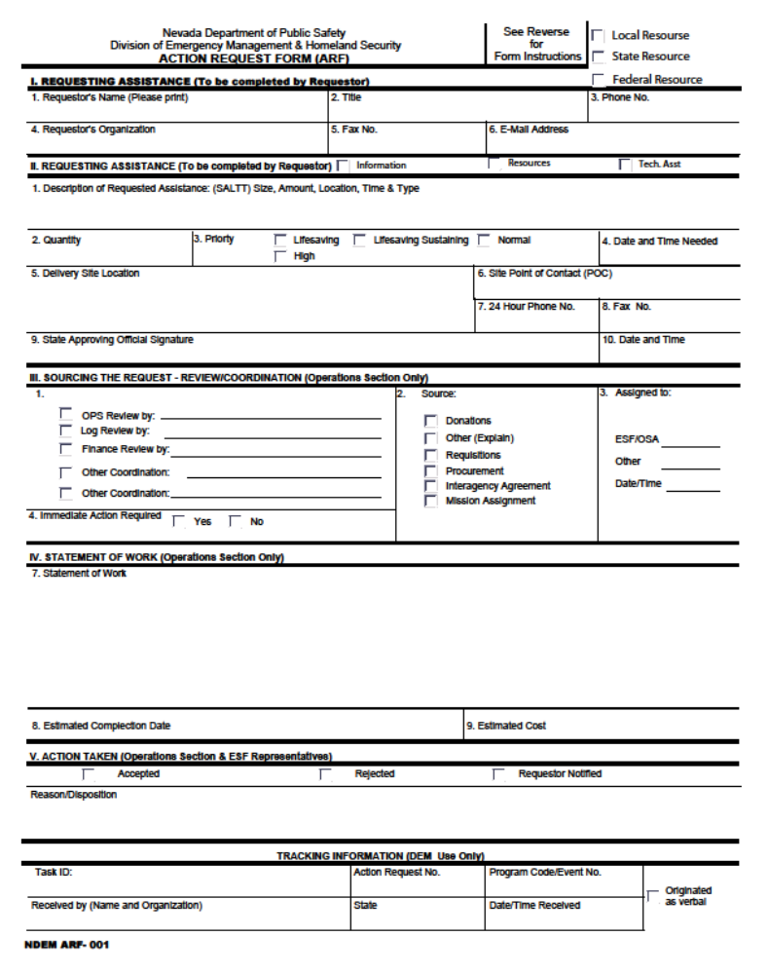

Reference, Worksheet, Sample | Description
Daily Checklist | This checklist is a helpful tool to assist the PIO complete daily activities.
Operational Planning “P” | The Operational Planning “P” is a guide to the process and steps involved in planning for an incident.
JIC Self-Assessment Survey | By filling out the JIC Self-Assessment Survey, the PIO and JIC Manager can use the information provided to staff JIC positions.
Daily Brief Worksheet | Information collected using the daily brief worksheet is provided during transition meetings.
Media Analysis Worksheet | This worksheet in assessing the content and accuracy of news media reports and assists in identifying trends and breaking issues.
Media/Social Media Analysis Worksheet | This worksheet assists in assessing the content and accuracy of news media reports and assists in identifying trends and breaking issues.
Query Record | This tool assists in keeping records of any inquiries or rumors reported.
Writing Guidelines for New Releases | These are guidelines to assist in writing news releases.
Sample News Release | This is a sample of a news release.
Media Briefing/Town Meeting Worksheet | This worksheet assists in preparing for a media briefing or town meeting.
Content and Writing Guidelines for Bloggers | These are guidelines to assist in maintaining an incident specific JIC blog.
Speaker Preparation Worksheet | This worksheet assists in preparing information that will be delivered via a media briefing or community meeting.
Spokesperson Request Worksheet | This worksheet assists in requesting spokespersons for media briefings.
Media Briefing Worksheet | This worksheet provides general guidelines and provides a sample moderator script for media briefings.
Field Escort Equipment and Communications Checklist | This checklist assists in ensuring that the media visiting the incident site are properly equipped and informed.
Opening Statement for Community Relations Interviews | This worksheet assists in performing interviews in order to obtain community feedback and information needs.
Sample Media Advisory (Media Briefing) | This is a sample of a media advisory for a scheduled media briefing.
Sample Media Advisory (JIC Established) | This is a sample of a media advisory announcing that the JIC has been established.
Sample Public Service Announcement | This is a sample of a public service announcement.
Public Exhibit and Discussion Diagram | This is an example of one of the types of community meetings that may be held.

DAILY CHECKLIST
Receive briefing from previous shift.
Develop and monitor information strategies in support of overall response effort.
Monitor Joint Information Center’s activities to ensure information strategies are being
followed.
Ensure public affairs people in field are given assignments.
Ensure necessary work space, materials, equipment and personnel are available or requested.
Receive approval from SEOC Manager on all information released from the JIC.
Maintain high level of understanding of current situation and response operations by attending Command and General Staff Briefings.
Ensure Status Board Specialist works with the Situation Unit to obtain the most current information.
Ensure information is being provided to internal and external stakeholders.
Monitor any request identified by either the SEOC Manager of JIC as “special.” VIPs, special interest, local issues, etc.
Provide SEOC Manager with timely information about external perceptions, concerns and needs
regarding the incident and response.
Ensure the speakers for the media briefings are prepared by the JIC well before the conferences.
Represent the SEOC Manager during all public functions where the actual members of the SEOC Manager are not in attendance.
Ensure appropriate and timely communications are maintained by the JIC with government,
community and media publics throughout the response.
Ensure all work of the JIC is well documented and delivered to the appropriate places.
Complete Daily Log (ICS-Form 214).
Brief incoming shift.

Planning “P”
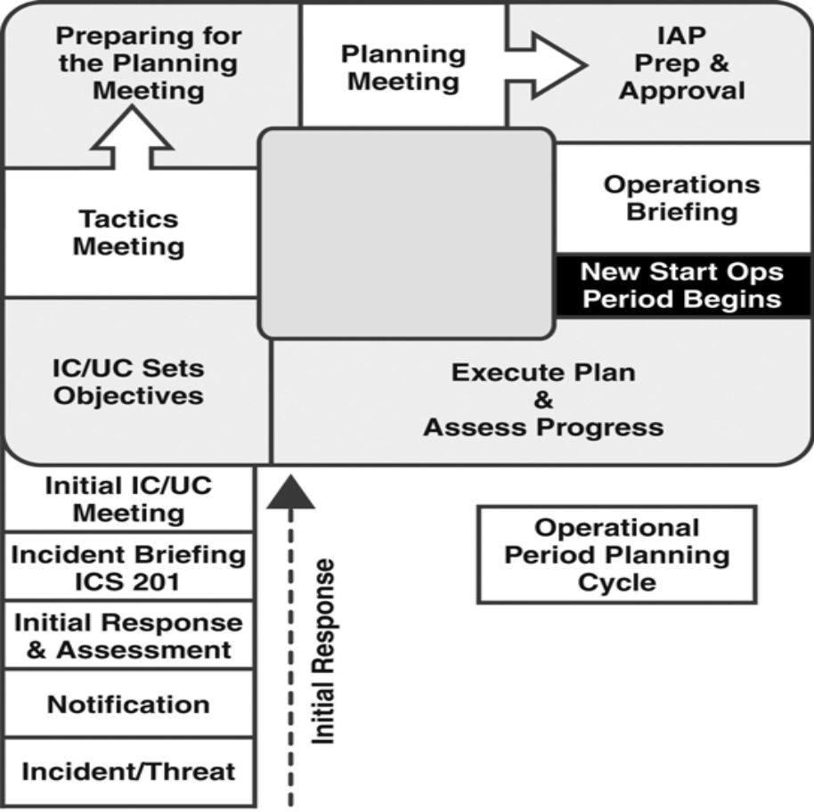
Planning “P”

- The Planning “P” is a guide to the process and steps involved in planning for an incident. The leg of the “P” describes the initial response period: Once the incident/event begins, the steps are Notifications, Initial Response & Assessment, Incident Briefing Using ICS 201, and Initial SEOC Meeting.

- At the top of the leg of the “P” is the beginning of the first operational planning period cycle. In this circular sequence, the steps are SEOC Develop/Update Objectives Meeting, Command and General Staff Meeting, Preparing for the Tactics Meeting, Tactics Meeting, Preparing for the Planning Meeting, Planning Meeting, IAP Prep & Approval, and Operations Briefing.

- At this point a new operational period begins. The next step is Execute Plan & Assess Progress, after which the cycle begins again.

JIC STAFF SELF-ASSESSMENT SURVEY
Welcome to the JIC! Please complete this survey, so our ESF #15 and JIC Manager can match your availability, experience, training, and preferences to the JIC Staff positions presently available.

First and Last Name: __________________________________________________________
Agency & Job Title: __________________________________________________________
Work Phone: ( ) Cell Phone: ( )
E-Mail Address: __________________________________________________________________
AVAILABILITY
Please list any dates/times or shifts that you are NOT available to work in the JIC:
_________________________________________________________________________________
RESOURCES
Please check any equipment/supplies or other JIC resources that you brought with you:
Laptop Printer Camera/Videocam Tape Recorder
Office Supplies Other: ___________________________________________
EXPERIENCE
How many years of public affairs experience do you have? ______________________________
How many times have you previously worked in a JIC? ______________________________
Describe what JIC roles or duties you have previously performed:
_________________________________________________________________________________
TRAINING
Please check which NIMS courses that you have completed:
None IS 700 IS 702 IS 800 ICS 100 ICS200
ICS 300 ICS 400
Have you completed any PIO or JIC training? Yes No ______________
Have you completed any media spokesperson training? Yes No ______________
SKILLS
Please check your “Top 3” best skills:
Supervising Developing Strategies Conducting Media Briefings and Interviews
Gathering Info Write Copying Taking Video/Photos Web Support
Answering Inquiries Investigating Rumors Computer Skills Admin Support
Other: ________________________________________________________________________
PREFERENCES
Please indicate which JIC role(s) or duties that you would like to be assigned to:
Preferred Roles: _________________________________________________________
No preference; I’ll work any role or duties as needed

Daily Brief Worksheet

1. Incident Name: | 2. Operational Period:
3. ESF #15: | 4. Prepared by:
5. Joint Information Center Personnel Assigned
APIO – JIC Manager: | APIO for Media Relations
APIO for Research and Writing | APIO for External Relations
APIO for Special Projects | Satellite JIC
6. Joint Information Center Daily Activities
6a. Information Gathering
Media monitoring & analysis highlights: | Rumor control highlights:
Social media monitoring & analysis highlights:

6b. Information Products
Written news releases: | Fact sheets:
Photographs: | Video:
PSAs: | Website:
Incident Social Media Websites:

6c. Media Relations
Media inquiry highlights: | Media interviews scheduled:
Media briefings scheduled: | Media speaker preparation scheduled/required personnel:
Field activities scheduled:

6d. Community Relations
Community inquiry highlights: | Community meetings scheduled:
Community speaker preparation scheduled/required personnel:

Media Assessment Worksheet
Date: / /
Media Outlet Name:
Radio TV Print Website Other
Current Release #:
Daily Broadcast Times:
(If recorded please mark Y or N after time)
Daily Cover Synopses:
Issues:
Inaccuracies:
View Points:
Fixes:
Who Replied To:
Media/Social Media Analysis Worksheet

Media/Social Media Source:

Date/Time/Length/Placement:

Spokespersons/Information Sources:

Facts/Statements:

Words/Phrases:

Visuals (pictures, analogies, anecdotes):

Key Messages/Themes:

Overall Evaluation/Follow-Up Issues:

Query Record

Person Calling:
Date/Time of Call:
Organization:
Phone/Fax Number:
Email Address:
Physical or Mailing Address:
Inquiry:
Deadline:
Person Taking Call:
Reply Made By:
Date/Time:
Reply:

WRITING GUIDELINES FOR NEWS RELEASES

- Assemble the facts into two or three sentences that answer – who, what, when, where, why and how.
- List the remaining facts in descending order of importance (i.e., the Inverted Pyramid journalism style) in narrative or, if necessary, bullet form (e.g., what agencies are responding, type and amount of equipment). NOTE: The release should be only one page in length. If there is a need for additional information about specific topics, then a separate fact sheet should be created. Follow steps 3 - 5 for fact sheets and news releases.
- Spell check and edit the release and give it to the APIO for Research and Writing and the ESF #15 for review and approval by SEOC Manager. (Review by subject matter specialists, technical experts and/or legal counsel may be helpful prior to approval by SEOC Manager.)
- Give copies of approved release to all JIC staff members or posting on Status Boards, inclusion in JIC Case Book and to respond to media and community inquiries.
- Email, fax or disseminate to media and other internal/external stakeholders.

SAMPLE NEWS RELEASE

(SEOC logos/names here)
News Release
Date: (date)
Contact: Joint Information Center
(###) ###-####

UNIFIED COMMAND RESPONDS TO (INCIDENT)

Carson City, Nevada - Write one sentence for the LEAD paragraph being as brief as possible. Include the most important information in this first sentence such as what happened, where, to who and when.
The BRIDGE paragraph is next and covers more detailed information than the lead. The release should be written in inverted pyramid style. Inverted pyramid means that you start with the most important information at the beginning of the release and the least important goes at the end. Why and how are mentioned here (if available) as well as secondary facts and identification (lead paragraphs do not contain names of individuals.)
The BODY section covers the remaining relevant information. Stick to the facts. Use active, not passive, voice. (e.g. Rather than writing “entered into a partnership” use “partnered” instead.) Use only enough words to tell your story. Beware of jargon. Avoid the hype. (The exclamation point (!) is your enemy.) Always have someone proof read your release and be prepared for changes.

###
(this signifies the end of the release)

Media Briefing Worksheet

Event | Date and Time
Location
Moderator
Speakers
Length of Conference
Exhibits:

Presenters | Handouts
2.
Presenters | Handouts
3.
Presenters | Handouts
4.
Presenters | Handouts
5.
Presenters | Handouts
Refreshments:
Special needs arrangements:
Notes:

CONTENT AND WRITING GUIDELINES FOR BLOGGERS

Reference: A U.S. government blog from the Office of Citizen Services and Communications, U.S. General Services Administration, http://blog.usa.gov/roller/
If a State Joint Information Center (JIC) blog is created, refer to these guidelines to successfully maintain your blog.
Content Guidelines
- Each post will be useful to the audience and the posts will show our readers how government resources are related to their everyday lives.
- Every entry will be related to one or more items about government information or services.
- The bloggers will establish themselves as government information experts because of their jobs and because of the innovative and creative ways they’ve used government information to make their lives better, easier and more interesting.
- Posts will key off the conversation in the blogosphere and from bloggers’ daily lives and experiences. Bloggers will read and research other blogs to stay aware of discussions in the blogosphere, especially as it relates to where we can provide useful government information and services to issues being widely discussed.
- Suggestions for posts are welcomed but the final say on what makes it on agency web will be determined by the blog team based on the purpose of the blog.
- Posts mentioning government-related sources or services should be about topics of interest to our audience in their everyday lives.
- Links will be provided to the resources websites blogs or articles referred to in posts.
- Posts can also link to related useful non-government blogs and sources as long as they are useful relevant, accurate, current and do not contain copyrighted images and explicit religious sexual, political, biased, or negative racial references.
- Bloggers will cite in posts the necessary link backs.
- Postings will not be an airing of job-related grievances or office relationships
- The blog will not serve as a way to communicate personal agenda.
- Bloggers will be balanced so they do not harm or show preferred treatment to any specific organization or product by brand.
- Use purchased images or government images in the public domain for entries.
- Bloggers must make sure they have royalty rights to use each photo or image
Writing Guidelines
- While blogging is a tool for communication, the JIC should limit the external or internal daily blogs. Each blogger will add a new post with text with graphics or audiovisual if desired.
- When necessary, PIOs will stand in for other team members who can’t blog on their appointed day.
- Each posting will not exceed 300 words and will be allotted no more than three hours of research writing and responding time.
- Each blogger will adopt a distinct and consistent voice and personality and the style will be candid, friendly, smart and informal. Bloggers will write under their first names.
- Each blogger will write relevant and specific titles and key words or tags for each posting.
- Bloggers will follow generally accepted grammar and agency writing guidelines – write to a language that is clear, concise and able to get the point of view to a diverse group
- Each blogger will respond to both positive and negative comments.
- The ESF #15 or SEOC Manager for the government connection will review for the connection balance and objectivity.
- Bloggers will not recommend or criticize specific companies’ brands or productions for personal opinions.
- Government facts about recalls, environmental sampling data, and other data can be used once approved by the SEOC Manager.
- Bloggers will not give specific advice (financial, medical, unconfirmed environmental data,) unless citing previously published government material.

SPEAKER PREPARATION WORKSHEET
1. Statement
2. Key Message(s)
3-4. Key Message(s) with Supporting Facts
5. Repeat Key Message(s)
6. Future Action(s)
SPOKESPERSON REQUEST WORKSHEET

Speaker’s Event:
Contact and Phone Number:
Date and Time Contacted:
Date of Event:
Time of Event:
Location:
Street Address or City:
Subject of Event:
Speaker Requested (if known):
Speaker Assigned:

Speaker’s Event:
Contact and Phone Number:
Date and Time Contacted:
Date of Event:
Time of Event:
Location:
Street Address or City:
Subject of Event:
Speaker Requested (if known):
Speaker Assigned:

MEDIA BRIEFING WORKSHEET
General Guidelines:
As the moderator it is your responsibility to set the tone for the media briefing.
Have a predetermined message for each media briefing. If you do not have a message, you do not need a media briefing.
Provide correct spellings for any of the names with peculiar spellings. Ensure you state the person’s position in the Unified Command.
Determine proper local pronunciations.
Set a time with your speakers prior to starting the media briefing. Stick to that time. Do not let any one person dominate the time during the media briefing. Take charge and use time as your authority.
Make yourself available at the end of the media briefing. This will build relationships and your trust and credibility with the members of the media attending your media briefing.
Moderator Script:
Welcome, Ladies and Gentlemen to today’s (this morning’s, tonight’s) MEDIA BRIEFING.
- We will be presenting information on _______ today.
- With us today is _______.
- We will begin today with some brief statements from the representatives of the Unified Command. Then we will open the floor to your questions. Because of on-going operations we will be available for ____ minutes today. Please allow time for everyone here to ask questions.
- Following the media briefing, the Joint Information Center Staff and I will be available to help you with any further needs.

FIELD PIO EQUIPMENT AND COMMUNICATIONS CHECKLIST

Personal Protective Equipment Notes:
Hard Hat
Goggles
Gloves

Communications:
VHF Radio
Cell Phone

Information
ICS 204
Latest situation status
Latest news release

OPENING STATEMENT FOR COMMUNITY RELATIONS INTERVIEWS
Example for Intercept Interview
Hello, my name is __________, and I’m from the Joint Information Center that is helping with the response to the incident (describe).
Do you live or work in this area?
We are asking a few community members to give us feedback on the incident.
We want to make sure we are getting you and all community members the information you want and need.
The questions will only take a few minutes to answer.
I can assure you that your answers will be kept in confidence.
First, let me ask…
Example for Telephone Interview
Hello, my name is ___________ , and I’m calling from the Joint Information Center that is helping with the response to the incident (describe).
Is this (state telephone number)?
We are asking a few community members to give us feedback on the incident.
We want to make sure we are getting you and all community members the information you want and need.
The questions will only take a few minutes to answer.
I can assure you that your answers will be kept in confidence.
First, let me ask….

SAMPLE MEDIA ADVISORY (MEDIA BRIEFING)

(SEOC logos/names here)
Media Advisory
Date: (date)
Contact: State Joint Information Center
(###) ###-####

(INCIDENT) RESPONSE MEDIA BRIEFING

WHAT: The (incident) State Emergency Operations Center is holding a media briefing at the incident command post today to discuss (response topic).
WHEN: (time, day)
WHERE: (building name) (room number, exact location) (street address) (city, state) (telephone number)
PARTICIPANTS: State On Scene Coordinator (name, agency), Responsible Party
BACKGROUND: (incident summary, something happened at some place some day.)

Please visit www.incidentwebsite.com for incident response information.

####

SAMPLE MEDIA ADVISORY (JIC ESTABLISHED)

(SEOC Logo/names here)
Media Advisory

Date: (date)
Contact: State Joint Information Center
(###) ###-####

(INCIDENT) JOINT INFORMATION CENTER ESTABLISHED

(CITY, State - ) The State Joint Information Center has been activated at the State Emergency operations Center to disseminate response information for the (incident).
The media is requested to use the phone numbers listed below for incident response inquiries and interviews.
(###) ###-####
(###) ###-####
(###) ###-####

A website with incident response information can be found at the following URL: www.incidentwebsite.com

####

SAMPLE PUBLIC SERVICE ANNOUNCEMENT

(DR##)-DR-(STATE)-(PSA##)
(DATE)
DISASTER INFORMATION FROM:
(Organization)
(Street Address)
(City, State, Zip)
MEDIA CONTACTS:
JIC (PIO name) (phone)
(State Agency) (PIO name) (phone)
PSA: APPLY FOR DISASTER ASSISTANCE BY PHONE
Kill date: until further notice
:20 SEC
NEVADANS WHOSE HOMES AND PROPERTY WERE DAMAGED BY THE RECENT (DISASTER) CAN APPLY FOR DISASTER ASSISTANCE BY PHONE. CALL THE JOINT INFORMATION CENTER TOLL-FREE AT 1-800-XXX-XXXX. IF YOUR HOME OR BUSINESS WAS DAMAGED BY THE (DISASTER)…AND IF YOU LIVE OR DO BUSINESS IN (COUNTY) OR (COUNTY)…YOU COULD BE ELIGIBLE FOR DISASTER ASSISTANCE…BUT YOU HAVE TO APPLY….CALL 1-800-XXX-XXXX. APPLY NOW.

Annex E: Acronyms

ACP: Area Contingency Plan
AOBD: Air Operations Branch Director
API: American Petroleum Institute
APIO: Assistant Public Information Officer
APR: Air/Purifying Respirator
AREP: Agency Representative
ASGS: Air Support Group Supervisor
ASOF: Assistant Safety Officer
BBL: Abbreviation for barrel
CAA: Clean Air Act
CDC: Center for Disease Control and Prevention
CEMP: Comprehensive Emergency Management Plan
CERCLA: Comprehensive Environmental Response, Compensation, and Liability Act of 1980 (42 U.S.C. 9601 et seq); also known as Superfund
CFR: Code of Federal Regulations
CHEMTREC: Chemical Transportation Emergency Center (1-800-424-9300)
CHRIS: Chemical Hazard Response Information System
COLREG: (USCG) Collision Regulations
COML: Communications Unit Leader
COMP: Compensation/Claims Unit Leader
COR: (USCG) Certificates of Registry
COST: Cost Unit Leader
COTP: (USCG) Captain of the Port

CRWB: Crew Boss/Crew Supervisor
CVM: (NOAA) Contingent Value Methodology
CWA: Clean Water Act
Decon: Abbreviation for decontamination
DOD: U.S. Department of Defense
DOE: U.S. Department of Energy
DHHS: U. S. Department of Health and Human Services
DHS: U.S. Department of Homeland Security
DOl: U.S. Department of Interior
DOJ: U.S. Department of Justice
DOL: U.S. Department of Labor
DOT: U.S. Department of Transportation
DWT: Dead Weight Tonnage
DINS: Damage Inspection Technical Specialist
DMOB: Demobilization Unit Leader
DPIC: Deputy Incident Commander
DOSC: (USCG) Deputy Operations Section Chief
DPRO: Display Processor
DIVS: Division/Group Supervisor
DOCL: Documentation Unit Leader
ENSP: Environmental Specialist
ENVL: Environmental Unit Leader
EBBS: (USCG) Electronic Bulletin Board System
EOC: Emergency Operations Center

EPA: U.S. Environmental Protection Agency
EQ: Environmental Quality
ERT: Emergency Response Team
ESD: Emergency Shutdown Device
ESF: Emergency Support Function
FACL: Facilities Unit Leader
FEMA: (DHS) Federal Emergency Management Agency
FOBS: Field Observer
FSC: Finance Section Chief
FDUL: Food Unit Leader
FAA: Federal Aviation Administration
FEMA: Federal Emergency Management Agency
FOG: Field Operations Guide (for ICS )
FOSC: Federal On-Scene Coordinator
FSC: Finance/Administration Section Chief
FWPCA: Federal Water Pollution Control Act
GSUL: Ground Support Unit Leader
GIS: Geographic Information System
GSA: General Services Administration
HazCom: Abbreviation for Hazard Communications Program (29 CFR 1910.1200)
HAZMAT: Hazardous Materials
Hazwoper: Abbreviation for Hazardous Waste Operations and Emergency Response (29 CFR 110.120)
HSPD: Homeland Security Presidential Directive
IAP: Incident Action Plan
IBRRC: International Bird Rescue Research Center

IC: Incident Commander
ICP: Incident Command Post
ICS: Incident Command System
IDLH: Immediately Dangerous to Life or Health
IMT: Incident Management Team
INTO: Intelligence Officer
JlC: Joint Information Center
LEL: Lower Explosive Limit
LNO: Liaison Officer
LNG: Liquefied Natural Gas
LPG: Liquefied Petroleum Gas
LOSC: Local On-Scene Coordinator
LSC: Logistics Section Chief
MEDL: Medical Unit Leader
MARPOL 73/78: International convention for the Prevention of Pollution from Ships, 1973, as modified by the Protocol of 1978
MSDS: Material Safety Data Sheet
MSHA: Mine Safety and Health Administration (federal)
NCP: National Oil and Hazardous Substances Pollution Contingency Plan (40 CFR 300)
NEPA: National Environmental Policy Act
NGO: Non-Governmental Organization
NIMS: National Incident Management System
NlOSH: National Institute for Occupational Safety and Health
NLS: Noxious Liquid Substance (33 CFR 151.47 or .49)
NMFS: National Marine Fisheries Service

NPRM: Notice of Proposed Rule Making (federal)
NOAA: National Oceanic and Atmospheric Administration
NRC: National Response Center; also Nuclear Regulatory Commission
NRDA: National Resource Damage Assessment
NRT: National Response Team
NSFCC: National Strike Force Coordination Center
NSSE: National Special Security Events
NVANG: Nevada Air National Guard
NVIC: Navigation and Vessel Inspection Circular
OPA 90: Oil Pollution Act of 1990
OSC: On-Scene Coordinator
OPS: Operations Section Chief
OSHA: Occupational Safety and Health Administration (federal)
OSRO: Oil Spill Response Organization
OPBD: Operations Branch Director
PEL: Permissible Exposure Limit
P & I: Protection and Indemnity Club
PlO: Public Information Officer
POC: Point-of-Contact
PSC: Planning Section Chief
PROC: Procurement Unit Leader
PPE: Personal Protection Equipment
PPM: Parts Per Million
PSC: Planning Section Chief
PSl: Pounds Per Square Inch.

PSlG: Pounds Per Square Inch Gauge
RCRA: Resource Conservation and Recovery Act
RESL: Resource Unit Leader
RRT: Regional Response Team
SARA: Superfund Amendments and Reauthorization Act of 1986
SCBA: Self-Contained Breathing Apparatus
SEOC: State Emergency Operations Center
SIT: Spontaneous Ignition Temperature (SIT); also abbreviation for Situation
SITL: Situation Unit Leader
SOSC: State On-Scene Coordinator.
SO: Safety Officer
SVBD: Service Branch Director
SCTL: Scientific Unit Leader
SITL: Situation Unit Leader
STAM: Staging Area Manager
SCKN: Status/Check-In Recorder
STVE: Strike Team Leader, Vessel
SPUL: Supply Unit Leader
SUBD: Support Branch Director
SSC: (NOAA) Scientific Support Coordinator
STEL: Short Term Exposure Limit
STORMS: Standard Oil Spill Response Management System
TAT: (EPA) Technical Assistance Team
TFLD: Task Force Leader
THSP: Technical Specialist
TIME: Time Unit Leader
TLV: Threshold Limit Value
TSCA: Toxic Substances Control Act
TSD: Treatment, Storage and Disposal Facility
TWA: Time Weighted Average
UC: Unified Command
UCS: Unified Command System
UEL: Upper Explosive Limit
USACE: U.S. Army Corps of Engineers
USCG: U.S. Coast Guard

USFWS: U.S. Fish & Wildlife Service
USGS: U.S. Geological Survey
USN: U.S. Navy
VOSS: Vessel of Opportunity Skimming System
VTS: (USCG) Vessel Traffic Service
WMD: Weapons of Mass Destruction

